CLUB EVENING TIME TRIAL COURSES

UC861: | (Evening 10 course)
Course Record:
Set by Jeff Jones 12 August 2009 with a time of 21:12
Sign on in Queens Field, Sutton Lane.

Start at Sutton Benger on B4069, opposite junction Sutton Lane. Continue through Christian Malford and on to Swallet Gate (SU990808) where turn left. Continue over bridge crossing M4 to junction to Dauntsey where turn right. Continue through Dauntsey to Little Somerford where turn left towards Great Somerford. Continue through Great Somerford and continue on to finish opposite junction with Upper Seagry Road at SU949801.
Map
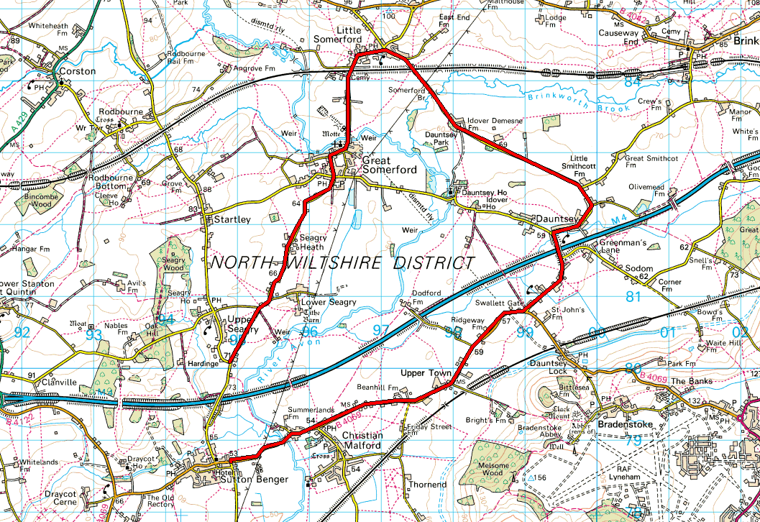
Your Course Notes (Personal Best, etc..)

UC862: | (Club ‘25’)
Sign on at ‘Wavin/Parsonage Way Industrial Estate’ (see Guidelines on Page 16)

Start on the B4069 between the junctions of Hill Corner Road and Parsonage Way on B4069 through Kington Langley to Sutton Benger *. Continue to Swallet Gate (SU990808) where turn left. Continue over M4 bridge to junction to Dauntsey where turn right. Continue through Dauntsey to Little Somerford where turn left. Continue through Great Somerford to Sutton Benger. At the junction with the B4069 turn left and complete the circuit from * to finish opposite junction with access road to disused pit (SU945792).
Map

Your Course Notes (Personal Best, etc..)

UC863: | (Sporting ‘15’ Lyneham & back B4069)
Course Record:

Sign on in Queens Field, Sutton Lane. (4 miles to start) (see Guidelines on Page 16)

Start on the B4069 in double lay bys in Kington Langley. Follow B4069 to Lyneham roundabout, junction B4069/A3012. Circle roundabout and retrace on B4069 to finish opposite start.
Map
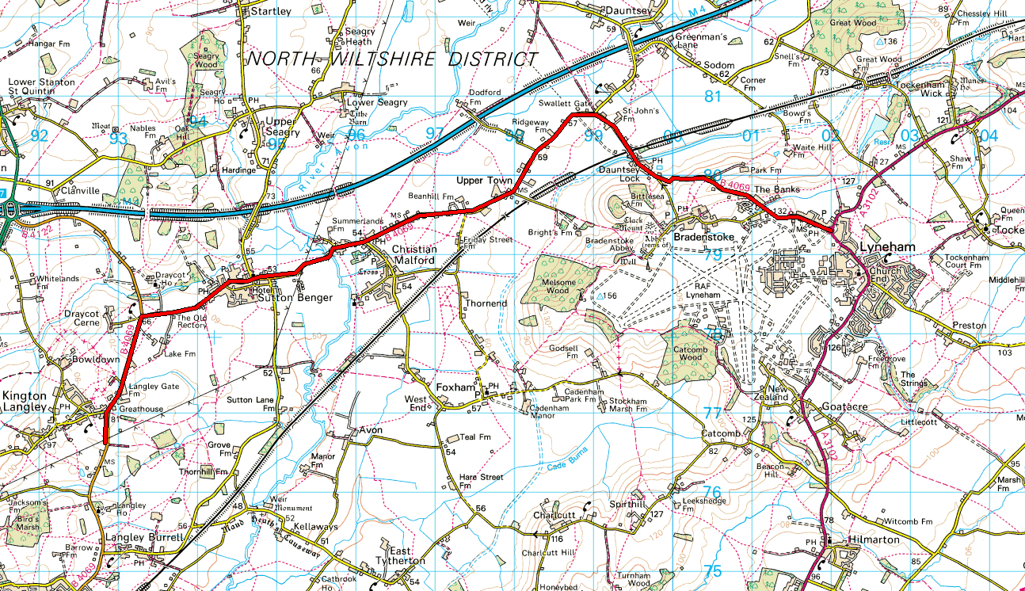

Your Course Notes (Personal Best, etc..)

UC863S: | (Lyneham Banks Sporting 10.6)
Course Record:

Sign on in Queens Field, Sutton Lane.

Sutton Benger to Lyneham & Back. (Shortened version of the UC863).
New course code for UC863S clashes with original UC863.

Map
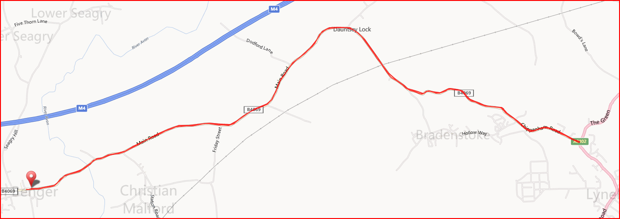

Your Course Notes (Personal Best, etc..)

U861/50: | (Club ‘50’)
Course Record:

Sign on in Queens Field, Sutton Lane. (4 miles to start)

Start at the junction of Idover Lane, Dauntsey and complete four circuits of ‘10’ course. Continue to Finish opposite junction with access road to disused pit (SU945792).
(May be held by West DC as U864)
Map
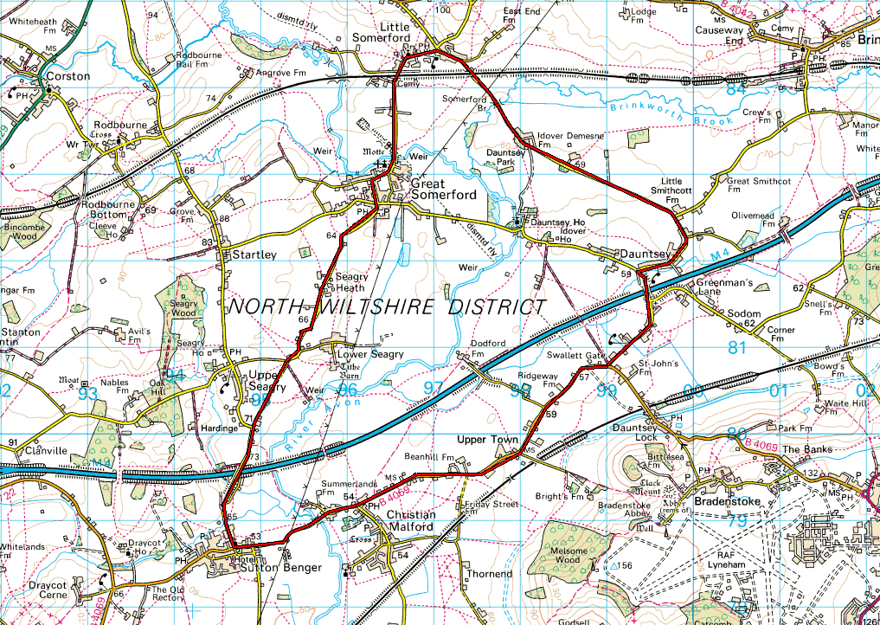

Your Course Notes (Personal Best, etc..)

U865: | (Sporting 10)
Course Record:

Sign on in Queens Field, Sutton Lane.

Stars Sutton Benger, finishes Upper Seagry

Start in opening 200m north of Vintage PH. Cross motorway, and pass through Great Somerford to Little Somerford, where left to junction with B4042, where left to Malmesbury ‘Hospital’ roundabout, where left onto A429 for 1km, then turn left (Grange Lane) and through Startley to finish at Upper Seagry adjacent to village hall.

Map
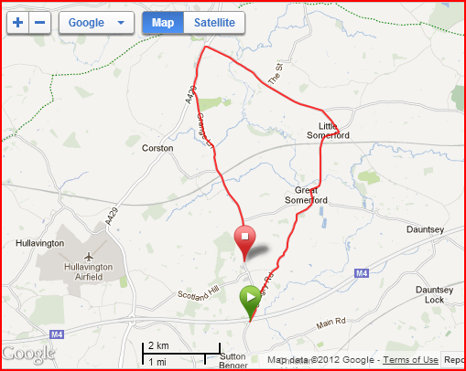

Your Course Notes (Personal Best, etc..)

U866: | (10 Mile Time Trial – The “Q” Course)
Course Record:
23:07 Simon Cox 15 August 2012
Sign on in Queens Field, Sutton Lane.

UC866: Starts Sutton Benger, finishes junction Dauntsey Lane/Green Lane
START (G.R. 950787) in High Street, Sutton Benger. Start is opposite junction with B4069.
Go East on B4069 (direction of Lyneham). Continue towards turn at Swallet Gatet. Turn left into Church Lane and 100m after crossing M4 Motorway bridge turn right across road into The Green. Continue North West to Little Somerford along The Idover Lane. Turn left by bus shelter in Little Somerford. Continue towards Great Somerford. In Great Somerford turn left into Dauntsey Road. Continue to finish 10m before junction of Church Lane and the Green at Dauntsey.

Map
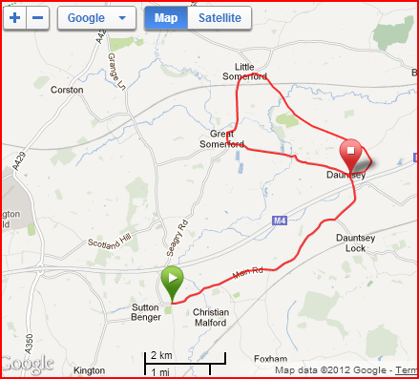

Your Course Notes (Personal Best, etc..)

UC867: | (The ‘P’ course)
Course Record:

Sign on in Queens Field, Sutton Lane.

Start at junction Upper Seagry Road (SU949801) to Great Somerford. Turn right to Dauntsey. At Dauntsey junction (SU994819) turn left. Continue through Dauntsey to Little Somerford, turn left towards Great Somerford. Continue through Great Somerford and finish 50 metres past junction with Upper Seagry Road.
Map

Your Course Notes (Personal Best, etc..)

U83: | (Sporting 24)
Course Record:

Sign on in Queens Field, Sutton Lane (2 miles to start)

Start on B4069 in double lay bys in Kington Langley. Proceed north through Sutton Benger and Dauntsey Lock to Lyneham where left at roundabout, onto A3102 to Wootten Bassett, where left into Whitehill Lane. After 1 ½ miles approx turn right under motorway and ascend Callow Hill towards Swindon-Malmesbury main road. At crossroads left onto B4042 towards Malmesbury. At Malmesbury roundabout take first exit (left) towards Chippenham. Take next left into Grange Lane, passing through Startley to finish adjacent to Upper Seagry Village Hall
Map
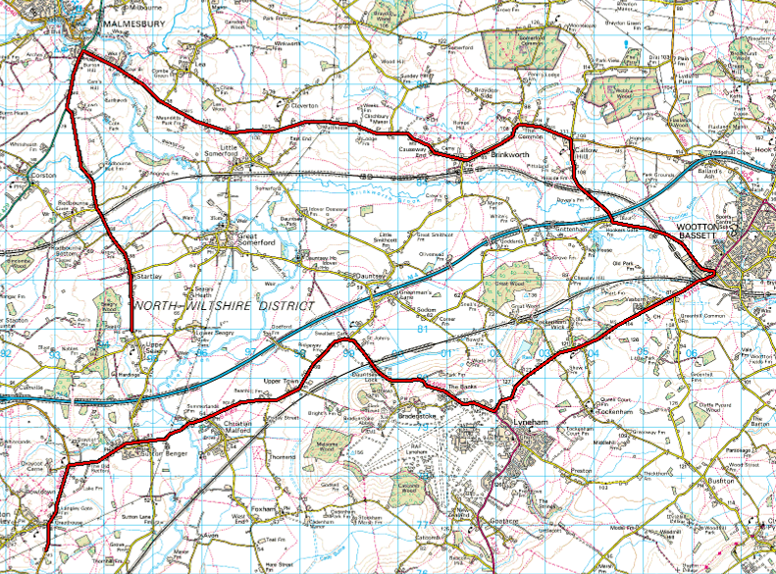

Your Course Notes (Personal Best, etc..)

U85: | 10 Mile Time Trial
Course Record:
New course – in use for Open Events

Park in area of Little Sommerford or Great Sommerford dependent upon location of event HQ.
Start in driveway of lane leading to Woodridge Golf course on B4042 (OS 003850).

Follow B4042 for 5 miles and circle RAB and retrace on B4042 towards Brinkworth. Go through Brinkworth to finish just past a small industrial unit (Sprayrite Car Body Repairs). Using boundary fence of next property as fixed 10 mile marker.

Map
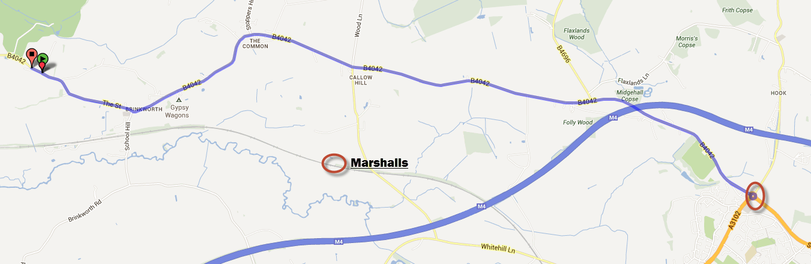

http://www.bikeroutetoaster.com/Course.aspx?course=614751

Your Course Notes (Personal Best, etc..)

U86: | 25 Mile Time Trial
Course Record:
New course – in use for Open Events
Park in area of HQ, Crudwell Village Hall, Tetbury Lane (north of start)

Start in layby / parking area northern end of Downs View (Garage), North of Murcott Lane, Crudwell on A429

Proceed south on A429 towards Malmesbury and at Water Tower RAB continue straight on. Turn left on A429 to RAB (Priory) at junction with B4042 towards Brinkworth and Royal Wotton Bassett. Through Brinkworth to Ballards Ash junction with B4696. Turn left to Purton Road X-roads. Turn left to Baydon Manor and Minety. At X-roads on B4040 turn left to Malmesbury Watertower RAB. Turn right at RAB towards Brinkworth to finish opposite scrap yard entrance.

Map
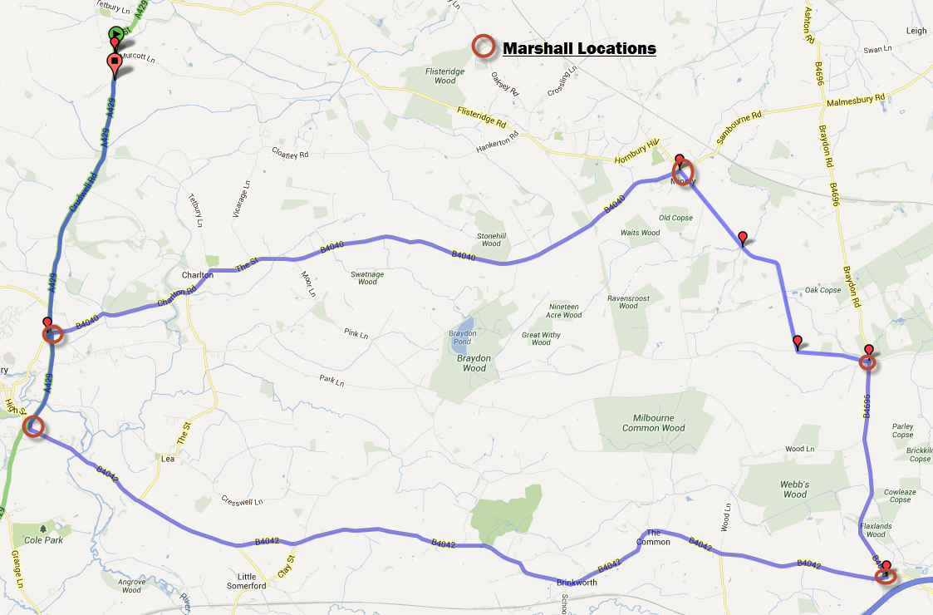

http://www.bikeroutetoaster.com/Course.aspx?course=612004

Your Course Notes (Personal Best, etc..)

UC 865: | (Sporting 10)
Course Record:

Sign on in Queens Field, Sutton Lane

Start in opening 200m north of Vintage PH. Cross motorway, and pass through Great Somerford to Little Somerford, where left to junction with B4042, where left to Malmesbury ‘Hospital’ roundabout, where left onto A429 for 1km, then turn left (Grange Lane) and through Startley to finish at Upper Seagry adjacent to village hall.

Map
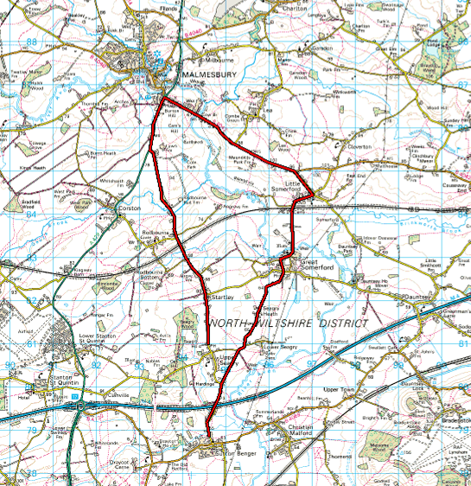

Your Course Notes (Personal Best, etc..

