Chippenham & District Wheelers Trophy Record
Chippenham Bicycle club was formed in 1879

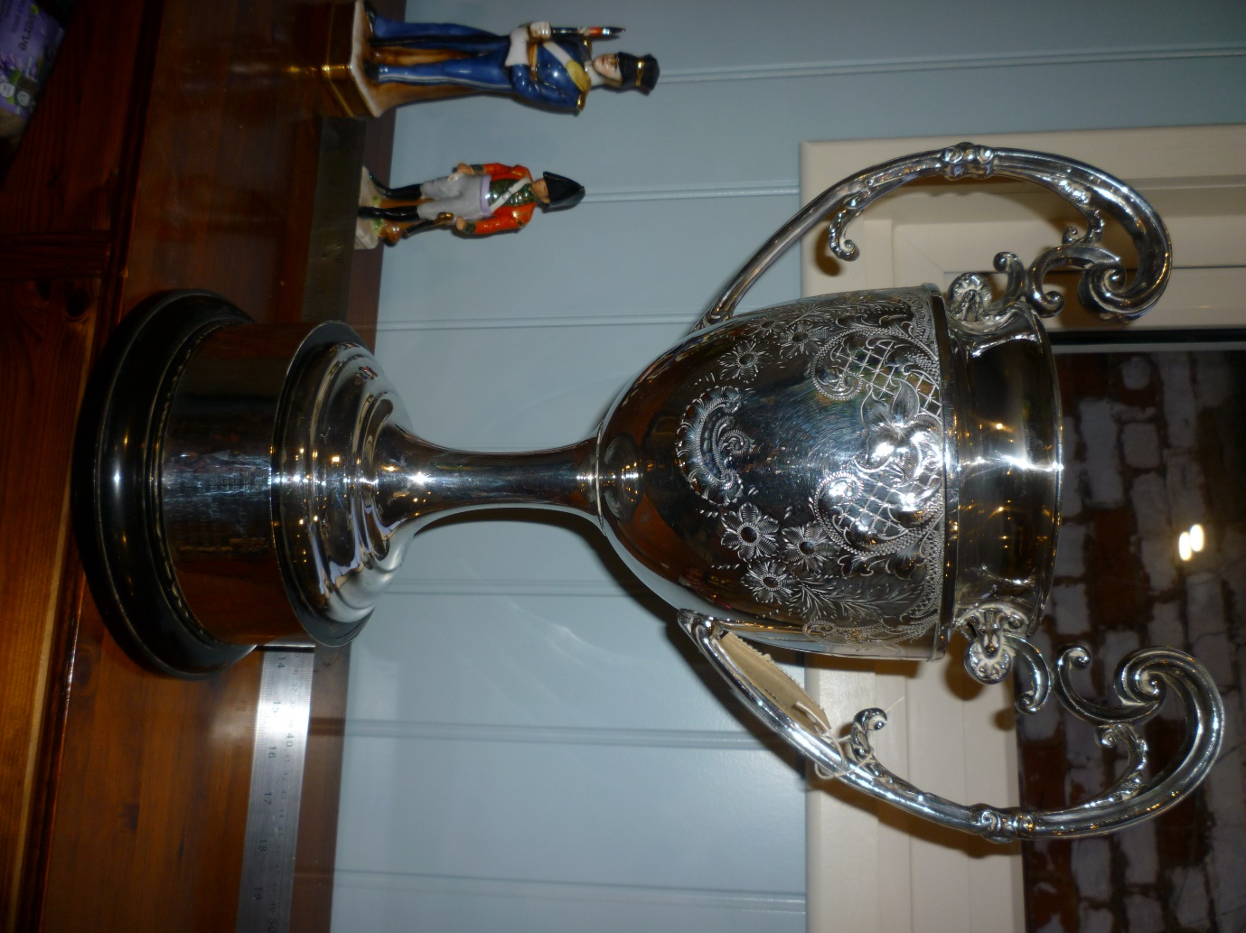
BEST ALL ROUNDER TROPHY
FIRST PRESENTED 1934
The Best All Rounder (BAR) Championship. The first claim member who returns the fastest average of average speeds achieved over 25, 50 and 100 miles holds the Best All Rounder Trophy for one year. Claims required as in Rule 8.

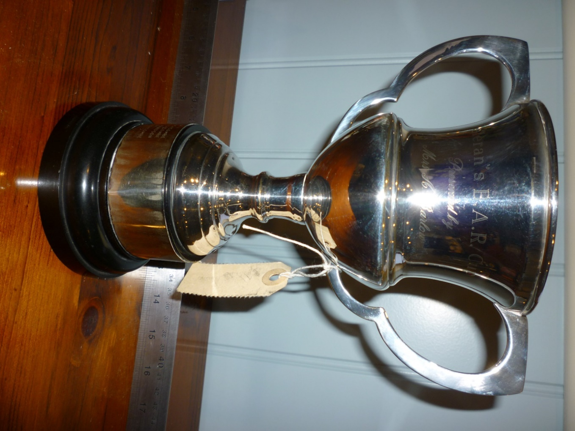
VETERAN’S B.A.R. CUP
PRESENTED BY
MRS A. BARLOW
FIRST PRESENTED 1974
Veterans Best All Rounder Championship. The first claim veteran member who returns the fastest average of average speeds achieved based on Veteran Time Trials Association (VTTA) standard times over 25, 50 and 100 miles will be the Veterans BAR Champion and hold the Veterans BAR Trophy for one year. Claims required as in Rule 8.

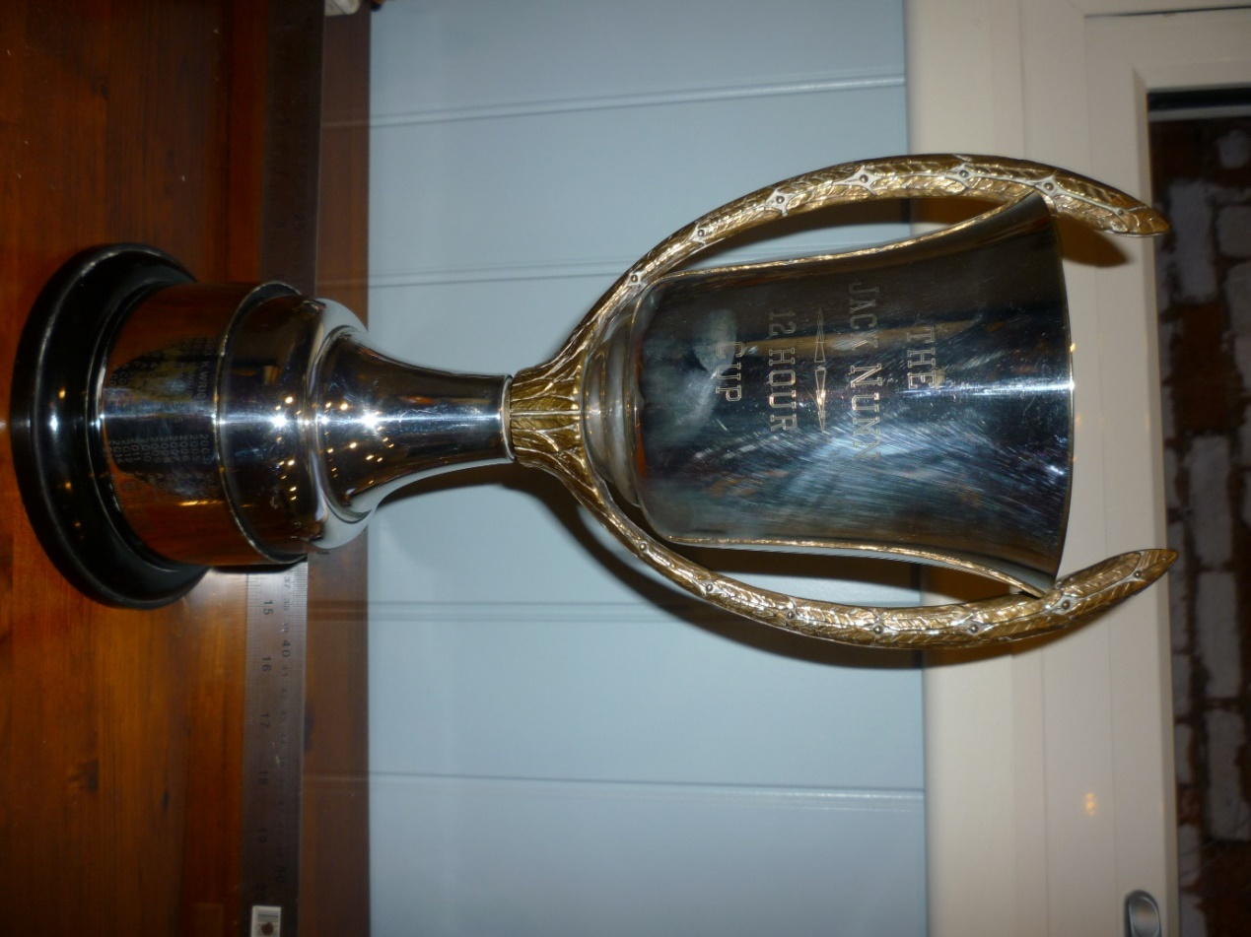
THE JACK NUNN
12 HOUR CUP
FIRST PRESENTED 1978
Jack Nunn Trophy. Awarded to the 1st claim member achieving the greatest number of miles in any Open 12 hour Time Trial. Claims required as in Rule 8.

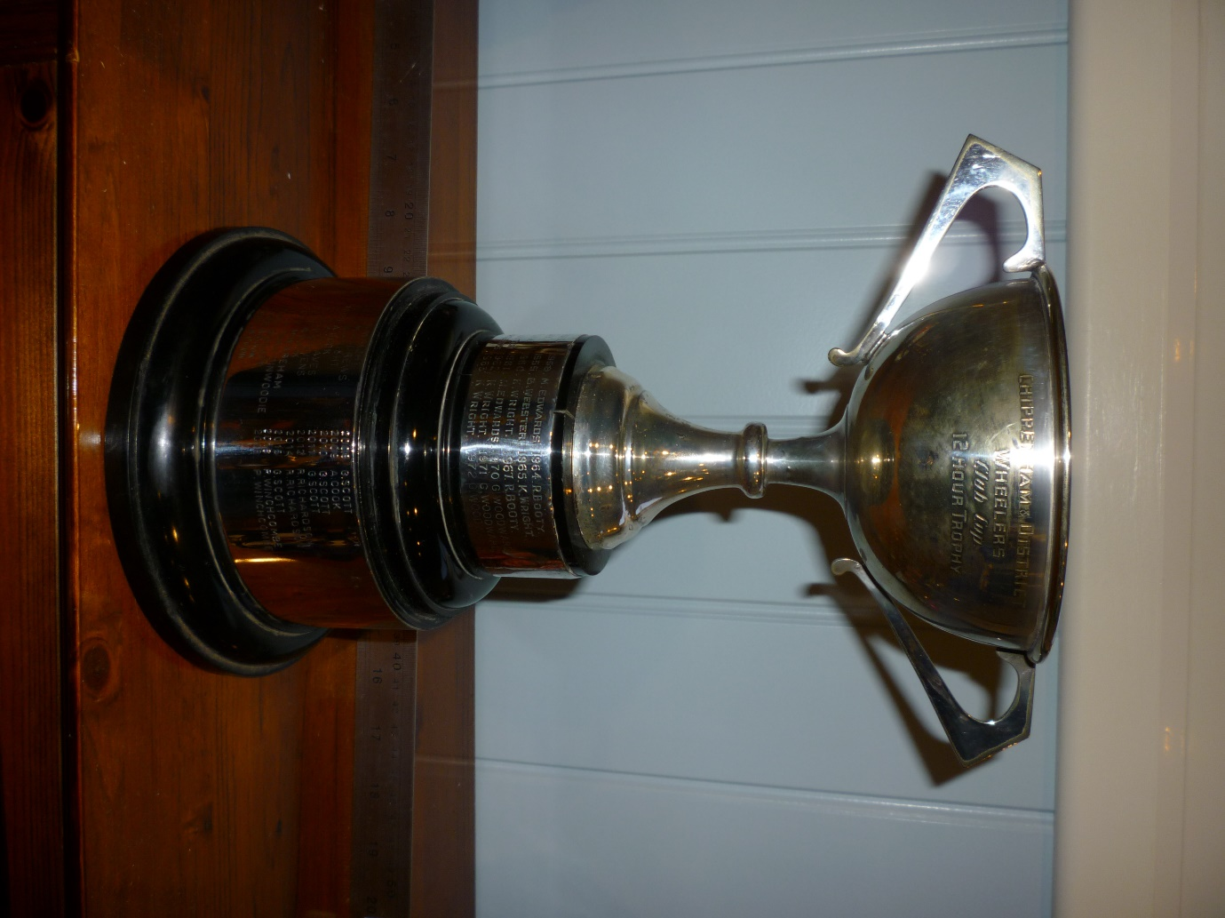
CHIPPENHAM & DISTRICT WHEELERS
CLUB CUP
12 HOUR TROPHY
FIRST PRESENTED 1953
(EPNS NEEDS RESILVERING)
12 hour Championship Cup. Awarded to the 1st claim member achieving the greatest number of miles in a designated 12 hour Time Trial.

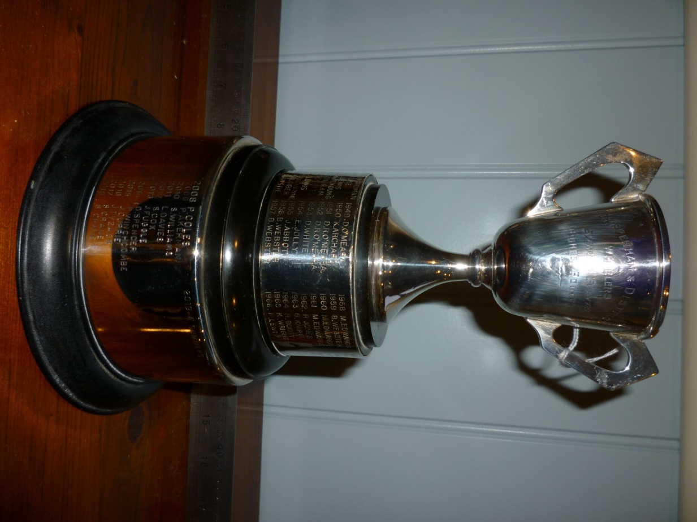
CHIPPENHAM AND DISTRICT WHEELERS
EVENING EVENTS
HIGHEST POINTS
FIRST PRESENTED 1949
AKA JACK NUNN HANDICAP TROPHY
Club Evening 10 mile Time Trial Cup. Awarded to the 1st claim member amassing the greatest number of points from the evening ‘Jack Nunn 10 mile Time Trial’ series. The award of the trophy is based on a handicapping system. 1 point per ride is awarded up to a max of 12 points (i.e. 12 rides at 1 point per ride). Only the best 6 handicap scores count towards overall points. The handicap is based on aggregate times from the best 6 previous year’s events, or for newcomers 2 times for that year taken from the first 4 rides (the fastest and slowest being discarded). Where a season’s rides are disrupted by using different courses the Competitive Events Co-ordinator may, with the committees approval, use that seasons result to calculate handicaps for all riders. The Competitive Events Coordinator will calculate the results. No claims required.

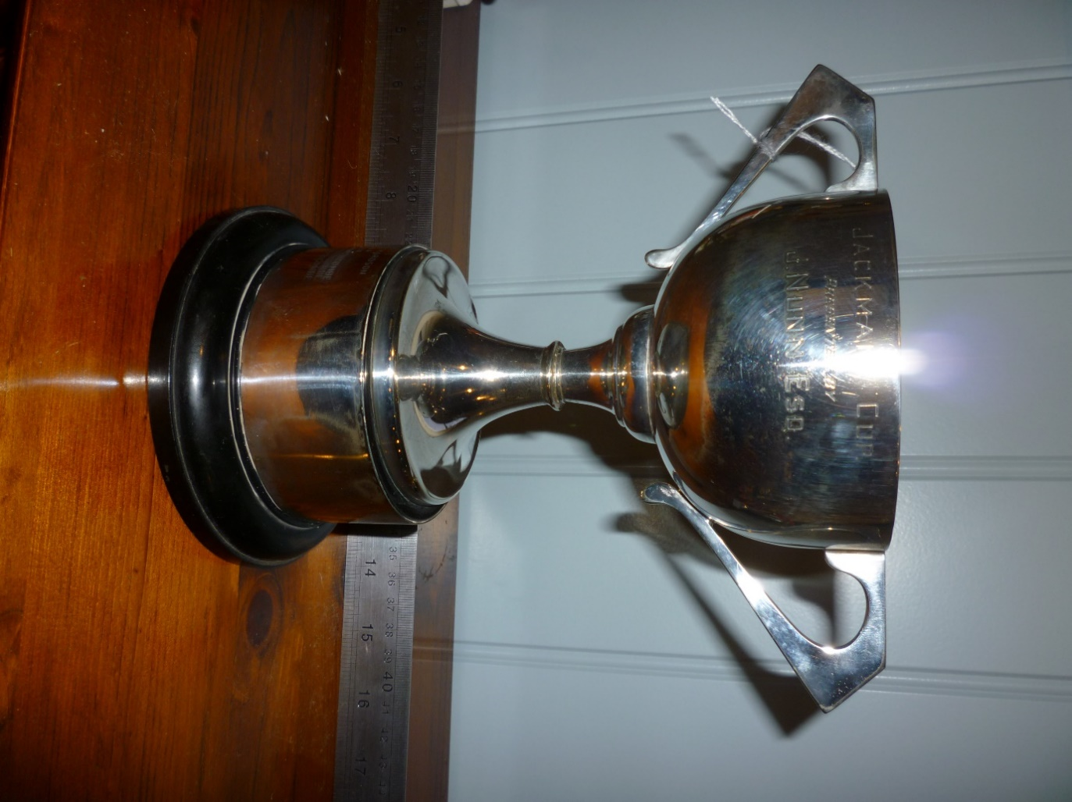
JACKMAN CUP
PRESENTED BY
J. NUNN ESQ
FIRST PRESENTED 1975
FOR 100 MILE TIME TRIAL
(EPNS NEEDS RESILVERING)

Jackman Cup. Awarded to the fastest time in a designated 100 mile Time Trial.
(The Jackman Cup was presented to the club by Jack Nunn. The engravers found the engraving instructions confusing and as we see today the trophy was engraved as the “Jackman Cup”.)
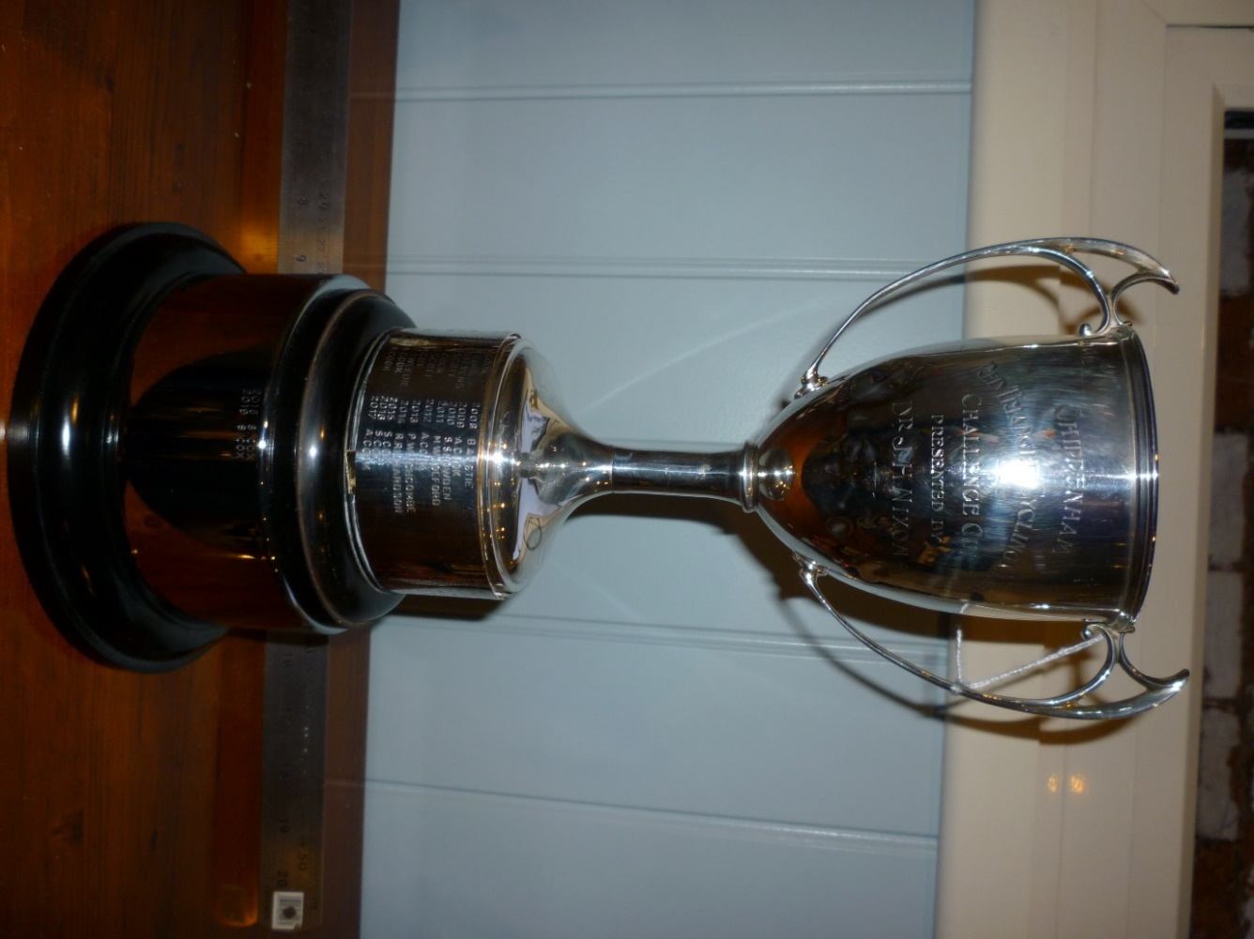
CHIPPENHAM RED TRIANGLE CYCLING
CHALLENGE CUP
PRESENTED BY
DR J.H. NIXON
THE NIXON CUP – 50 MILE TIME TRIAL
FIRST PRESENTED 1946
Nixon Cup. Awarded to the fastest rider in a designated Club 50 mile Time Trial.
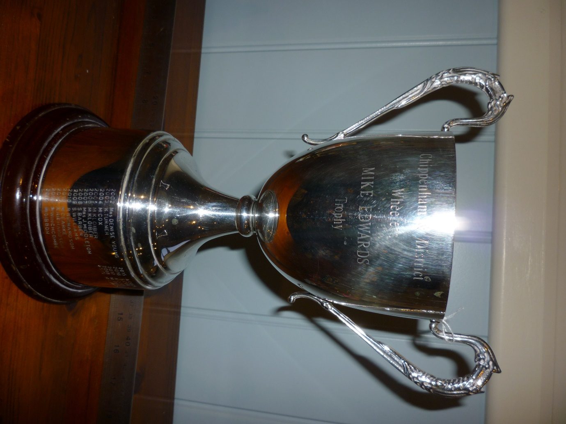
CHIPPENHAM & DISTRICT WHEELERS
MIKE EDWARDS
TROPHY
FIRST PRESENTED 2002
50 MILE TIME TRIAL
Mike Edwards Cup. Awarded to the fastest rider on handicap in a designated Club 50 mile Time Trial.

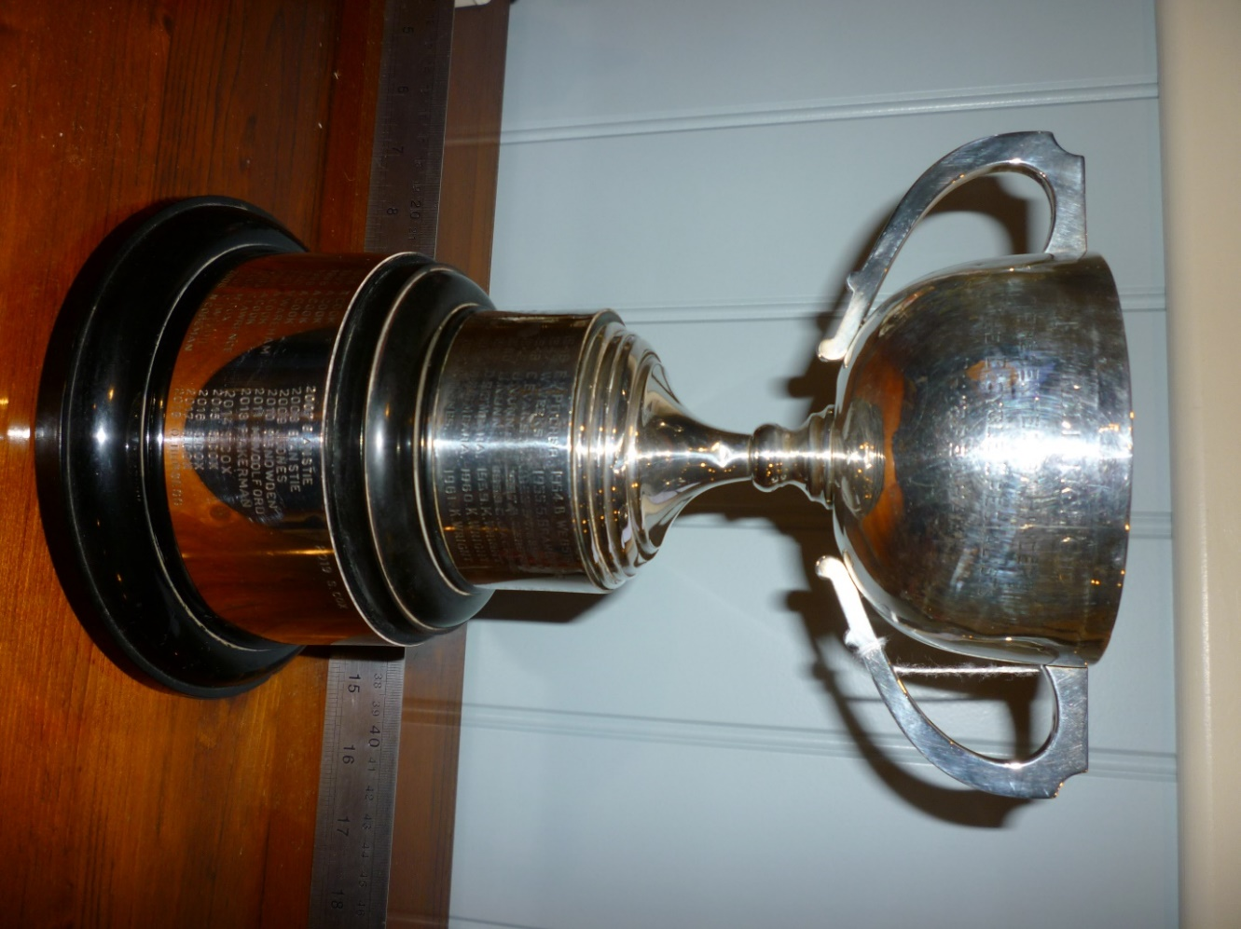
THE RELIANCE CUP
PRESENTED BY HINDERS
THE BICYCLY SPECIALISTS
CHIPPENHAM
THE HINDER CUP – CLUB EVENING 25 MILE TIME TRIAL
FIRST PRESENTED 1946
Hinder Cup. Awarded to the fastest rider in a designated Club 25 mile Time Trial.
(usually a club evening 25 mile time trial)
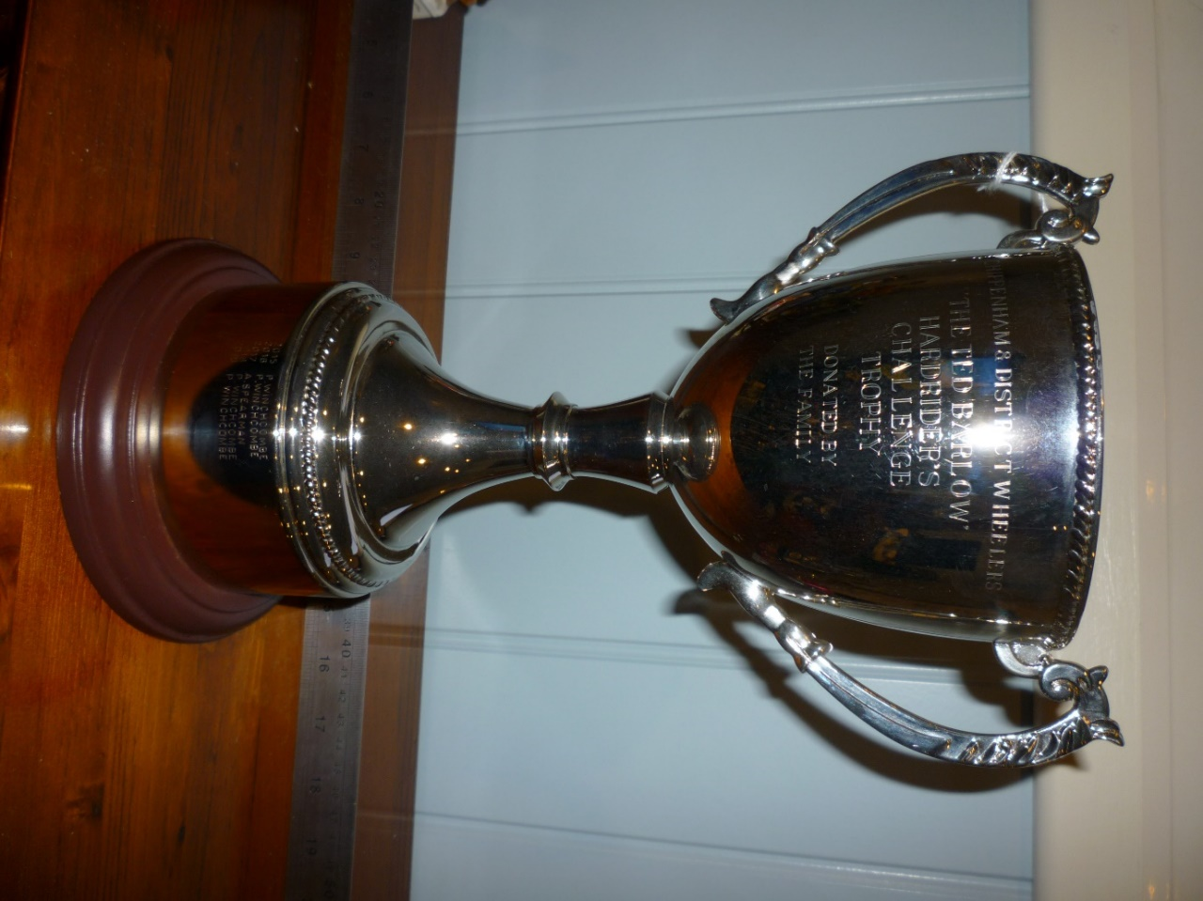
THE TED BARLOW
HARDRIDERS CHALLENGE TROPHY
DONATED BY THE FAMILY
FIRST PRESENTED 2015
Ted Barlow Hardriders Challenge Trophy. Awarded to the 1st claim member achieving the highest points total based on results in the Western Time Trial Association (WTTA) Hardriders Series where points are awarded relative to the finishing position of Chippenham Wheelers riders in each event within the overall field. If the WTTA series is not run then a set of equivalent events will be nominated and the results calculated in the same way. The placing will be based on the best 6 rides as per the WTTA Hardrider rules or the highest points scoring Chippenham Wheeler in the event that no rider has completed 6 events (i.e. any points gained in the series will count towards the trophy but a rider completing 6 events would qualify over a rider with more points who only took place in 5 events). Claims are not required as results will be taken from the WTTA Results or calculated by the Racing Secretary.

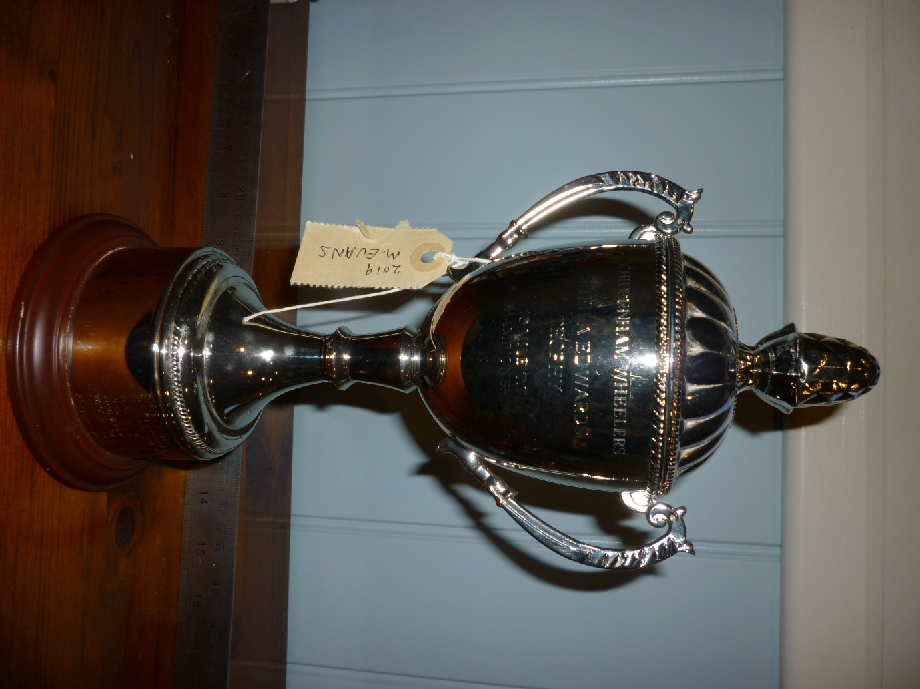
CHIPPENHAM WHEELERS
SHEILA EDWARDS TROPHY
10 MILE TT CHAMPIONSHIP
EVENING 10 MILE TT
FIRST PRESENTED 2011
Not actually in the rule book!
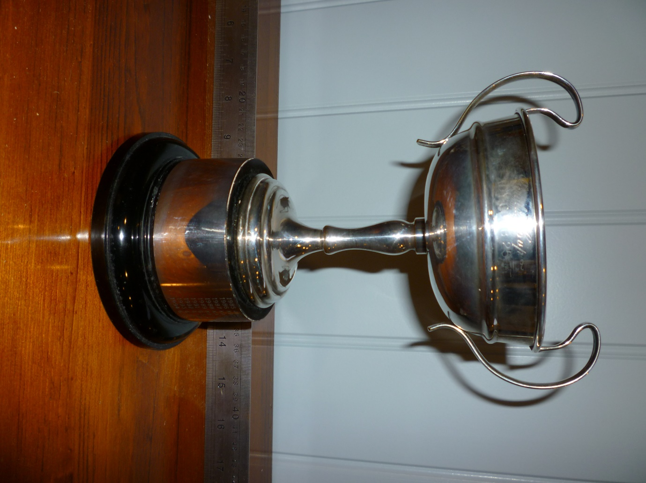
GERALD CUP
LADIES 25 MILE TIME TRIAL
FIRST PRESENTED 1985
Gerald’s Cup. Awarded to the fastest lady rider in a designated Club 25 mile Time Trial.
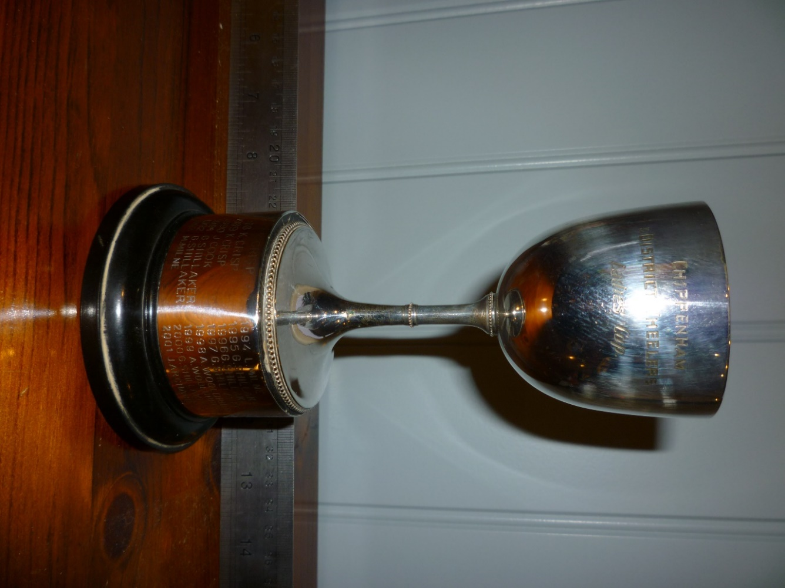
CHIPPENHAM WHEELERS
LADIES CUP
FIRST PRESENTED 1953
Ladies Best All Rounder (BAR) Championship Cup. The 1st claim Lady Member who returns the fastest two performances in 10 mile events and the fastest two performances in 25 mile events (calculated as in Rule 10) shall be the Ladies Time Trial Champion and shall hold the Ladies Championship Cup for one year. Claims required as in Rule 8.

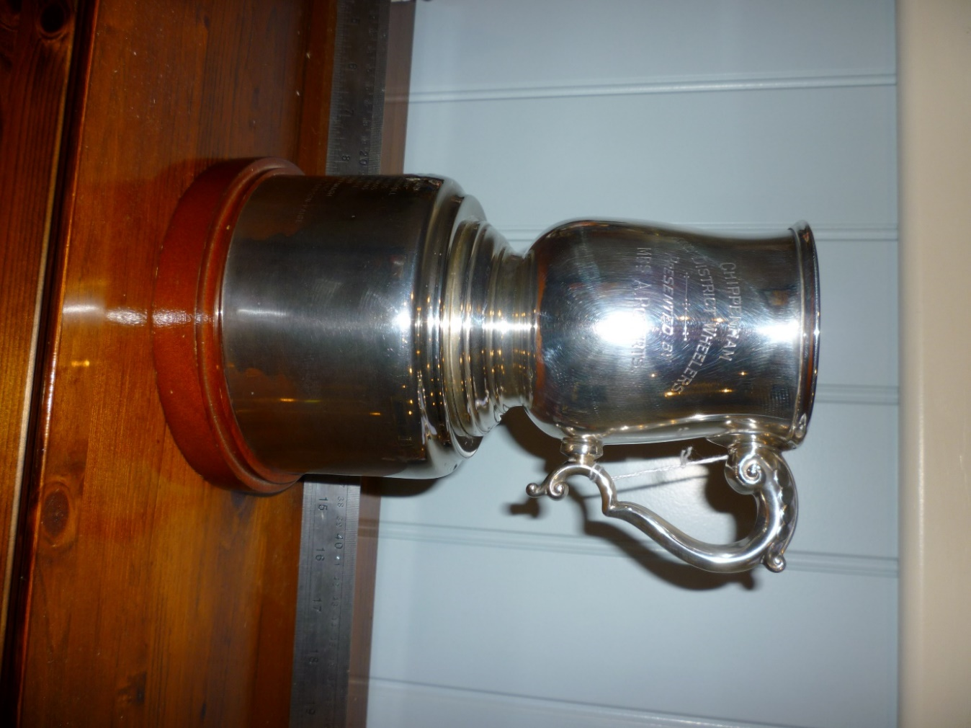
CHIPPENHAM AND DISTRICT WHEELERS
PRESENTED BY
MRS A. ROBERTS
THE ROBERTS TANKARD – CLUB HILL CLIMB
Hill Climb (Roberts Tankard). Tankard awarded to fastest 1st claim rider in a designated event.

FIRST PRESENTED 1957

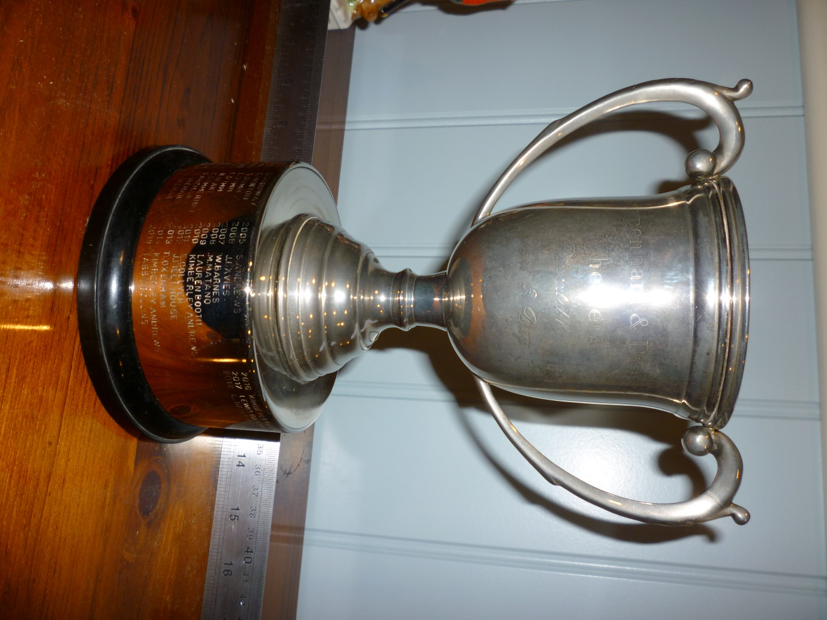
CHIPPENHAM AND DISTRICTED WHEELERS
PRESENTED BY
MRS E. DAY
FIRST PRESENTED 1978
The Mrs Day Cup. Awarded to the 1st Claim Youth member amassing the greatest number of points in the Youth Evening under 5 mile Time Trial series. Points to be awarded on handicap times, the best six performances to count, with one point awarded for each ride completed.

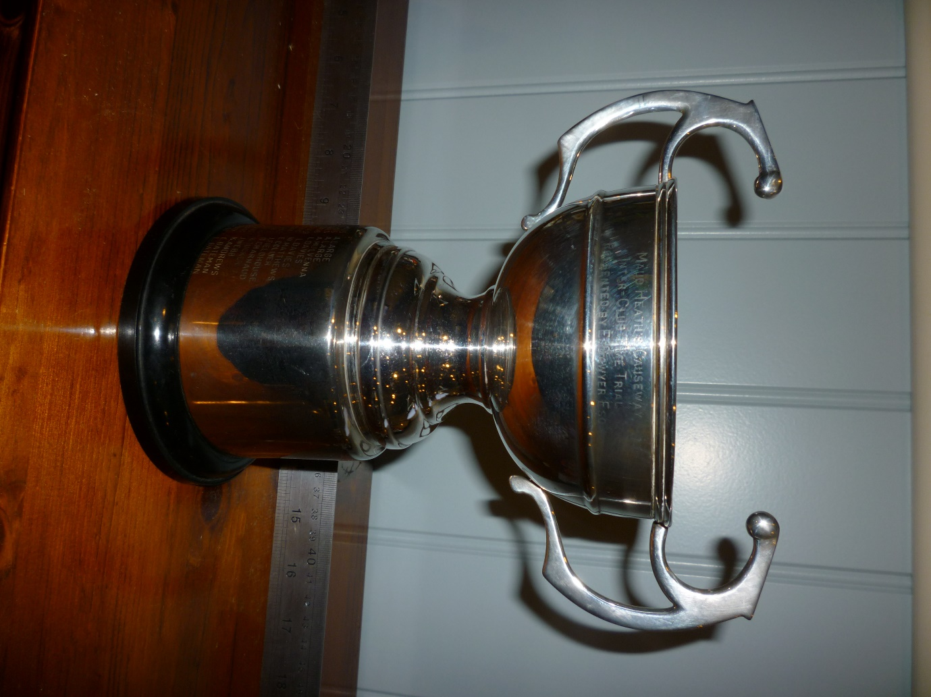
MAUD HEATH’S CAUSEWAY
INTER-CLUB TIME TRIAL
PRESENTED BY E. SAWYER ESQ
THE TED SAWYER CUP
FIRST PRESENTED 2005
The Ted Sawyer Cup. Awarded to the 1st claim Youth Member recording the fastest aggregate time in the Youth Evening under 5 mile Time Trial series over 6 events.
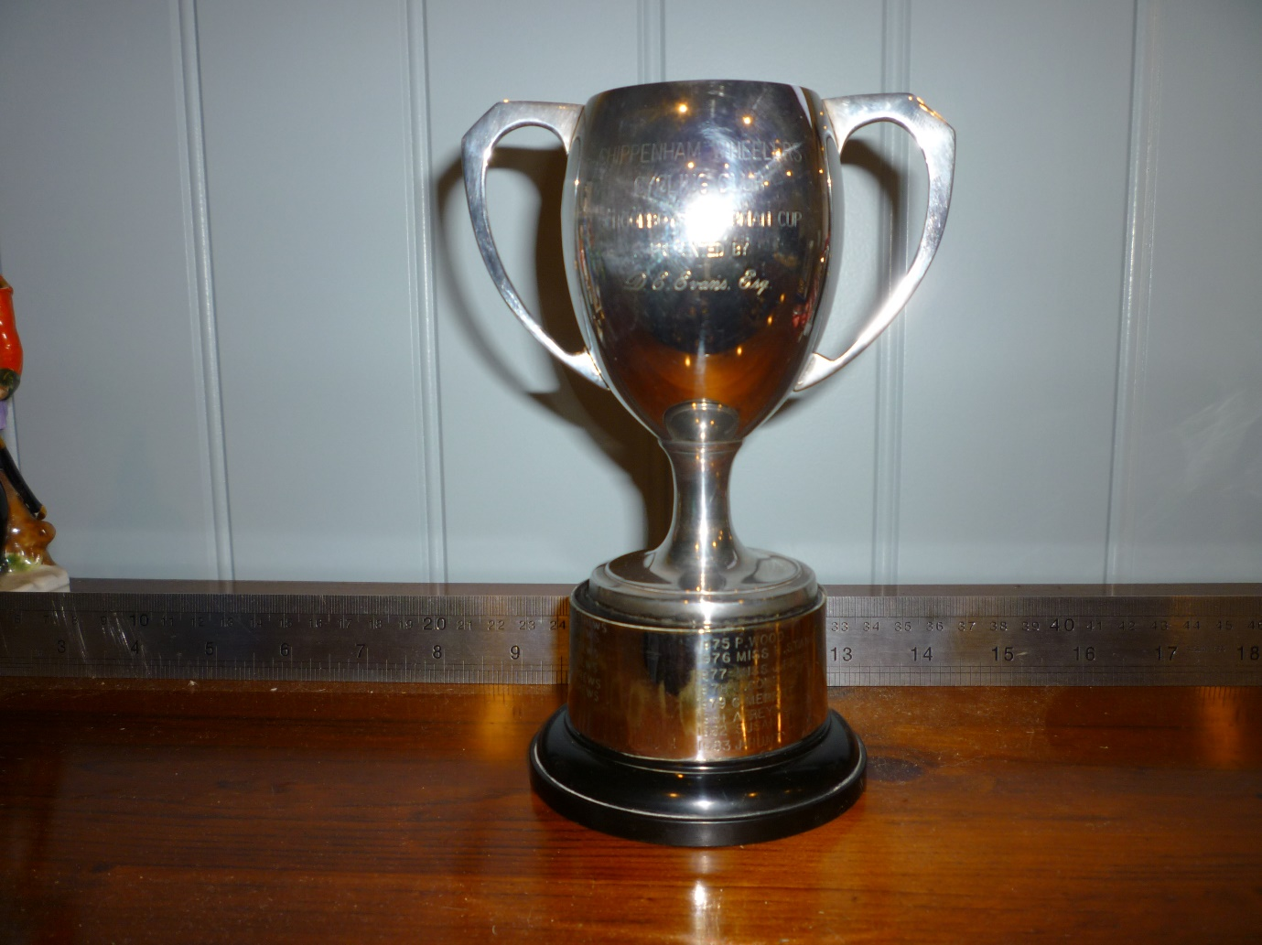
CHIPPENHAM WHEELERS CYCLING CUP
SCHOOL BOY CLUBMAN CUP
PRESENTED BY
D.E. EVANS ESQ
FIRST PRESENTED 1975
Youth Activities Award (David Evans Clubman Cup). Awarded to the 1st Claim Young Wheeler amassing the greatest number of points awarded for Club and Cycling activities. Note: Young Wheeler Log Book or other proof required by the points co-ordinator. Member must be aged 15 or under at time of participation.

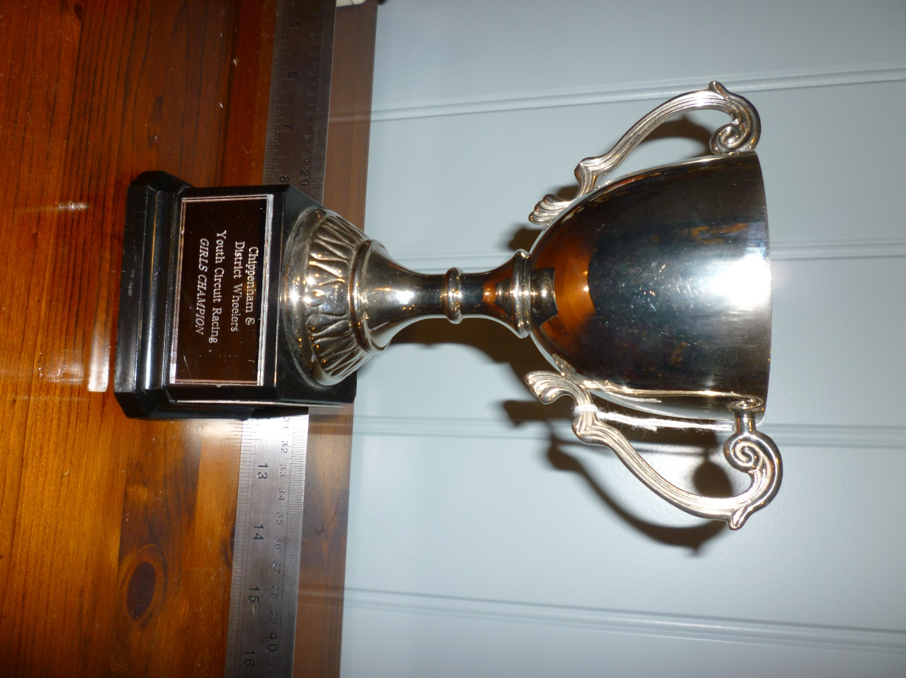
CHIPPENHAM & DISTRICT WHEELERS
YOUTH CIRCUIT RACING
GIRLS CHAMPION
FIRST PRESENTED 2010
Girls Youth Circuit Trophy and Junior Road Race Trophy. To be open to all 1st claim girls competing in open road races and circuit races on a points basis, to be awarded based on the number of British Cycling points obtained.

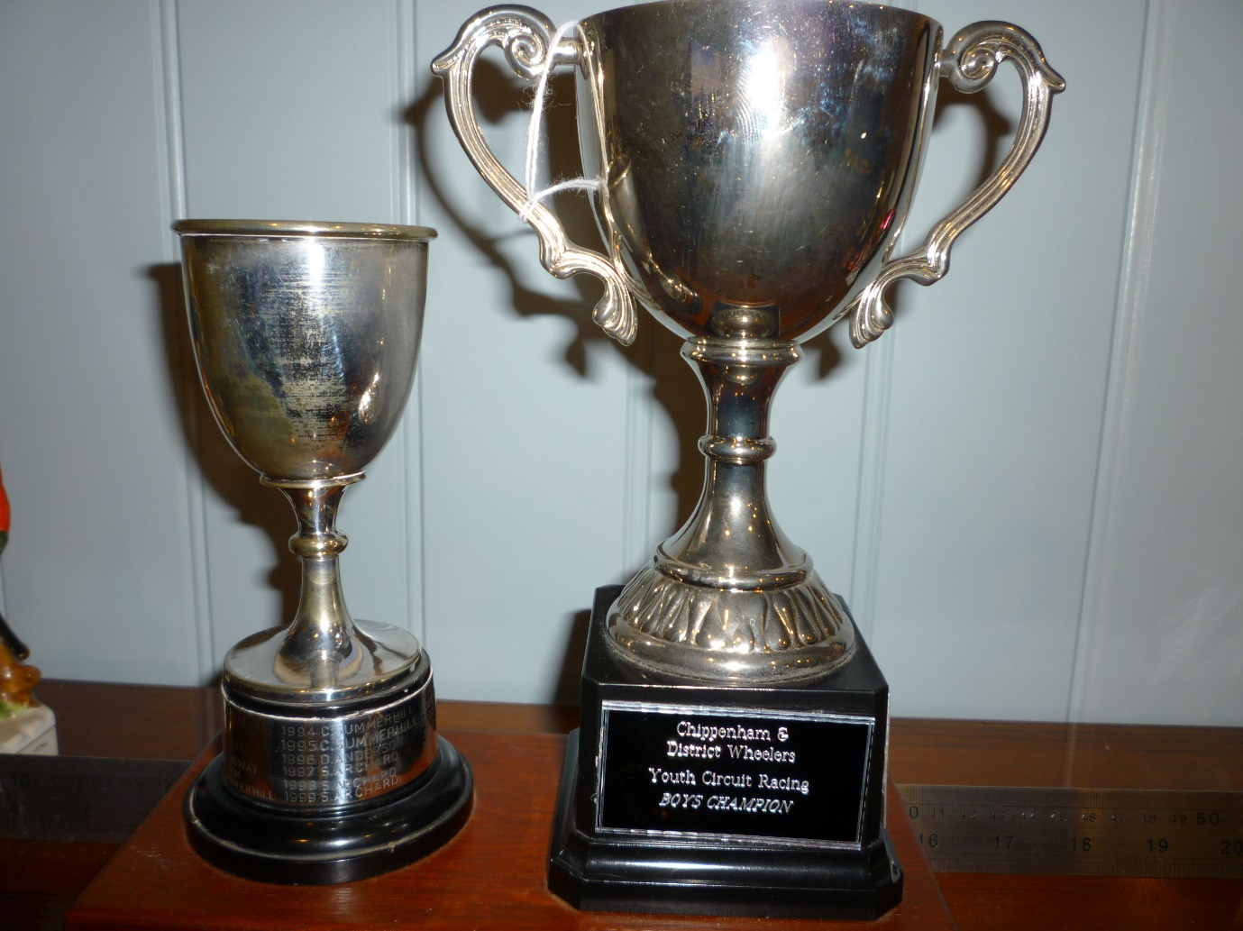
CHIPPENHAM & DISTRICT WHEELERS
YOUTH CIRCUIT RACING
BOYS CHAMPION
FIRST PRESENTED 2010
ON LEFT GEORGE HILL CUP – FIRST PRESENTED 1974
(EPNS NEEDS RESILVERING)
Boys Youth Circuit Trophy and Junior Road Race Trophy. To be open to all 1st claim boys competing in open road races and circuit races on a points basis, to be awarded based on the number of British Cycling points obtained.

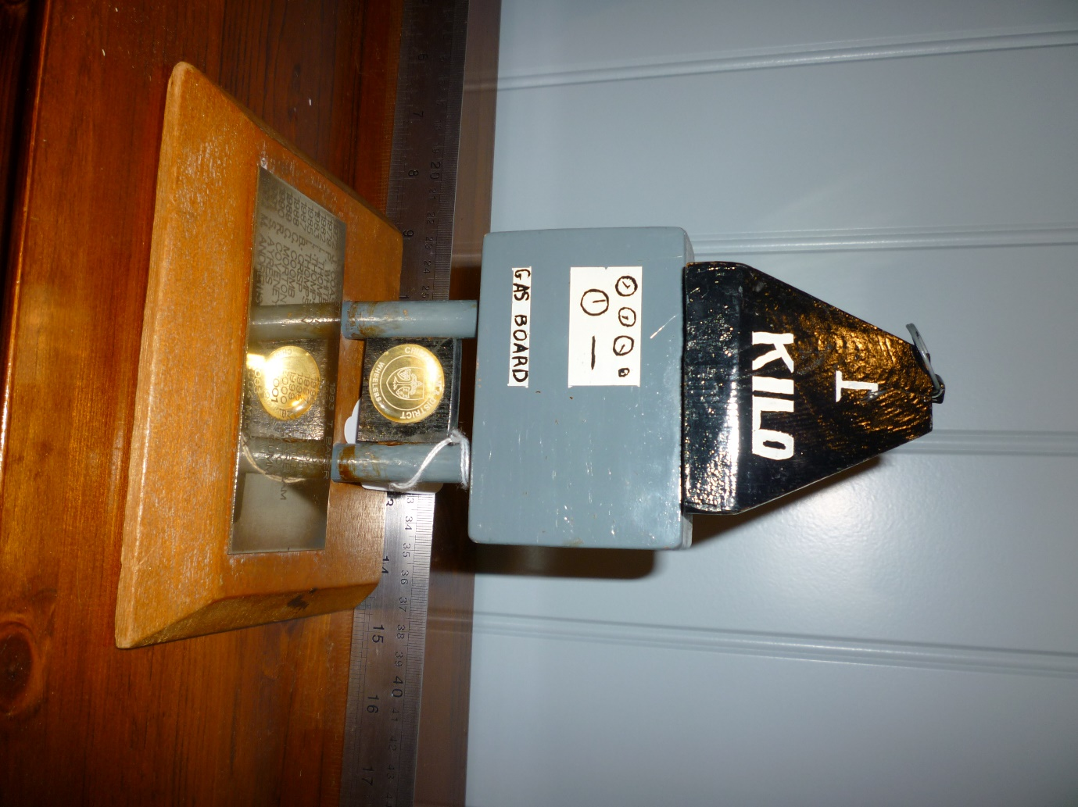
FIRST PRESENTED 1971
Kilometre (Kilo). Trophy Awarded to the fastest time in a designated Club 1 kilometre Time Trial.

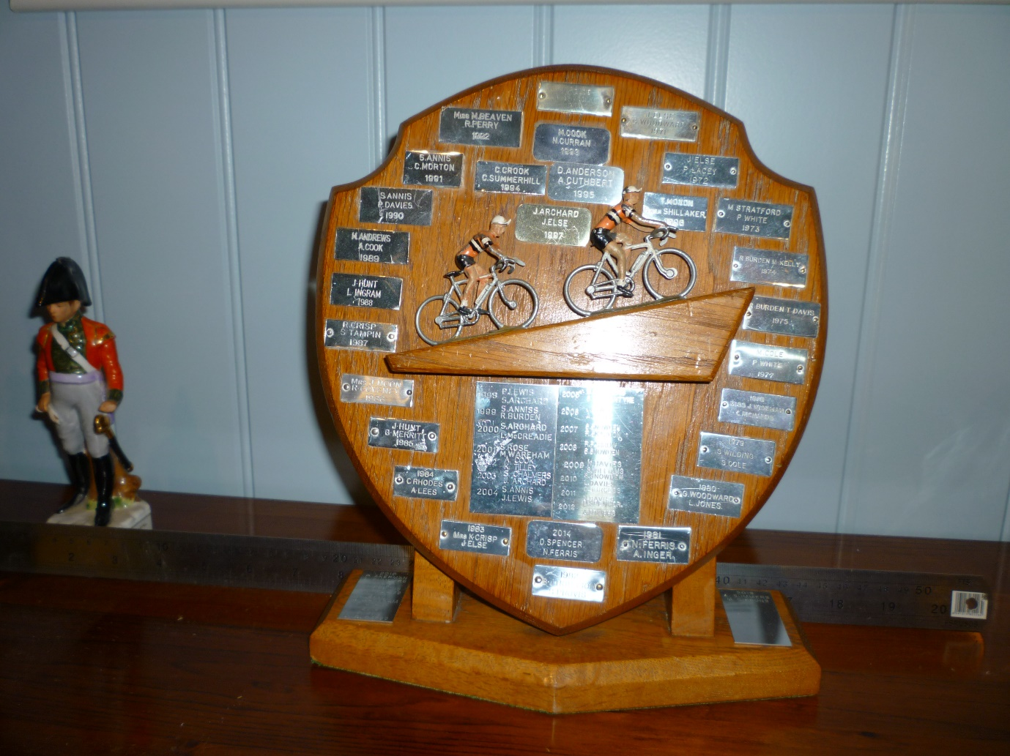
2 UP TIME TRIAL SHIELD
FIRST PRESENTED 1970

Club 2-up Team Trophy. Awarded to the fastest team of 2 riders in a designated event based on the fastest handicap time. Medals awarded to the fastest team. Teams to be based on a lottery to be drawn 7 days prior to the event. Open to 2nd claim members providing they are paired with a 1st claim member.

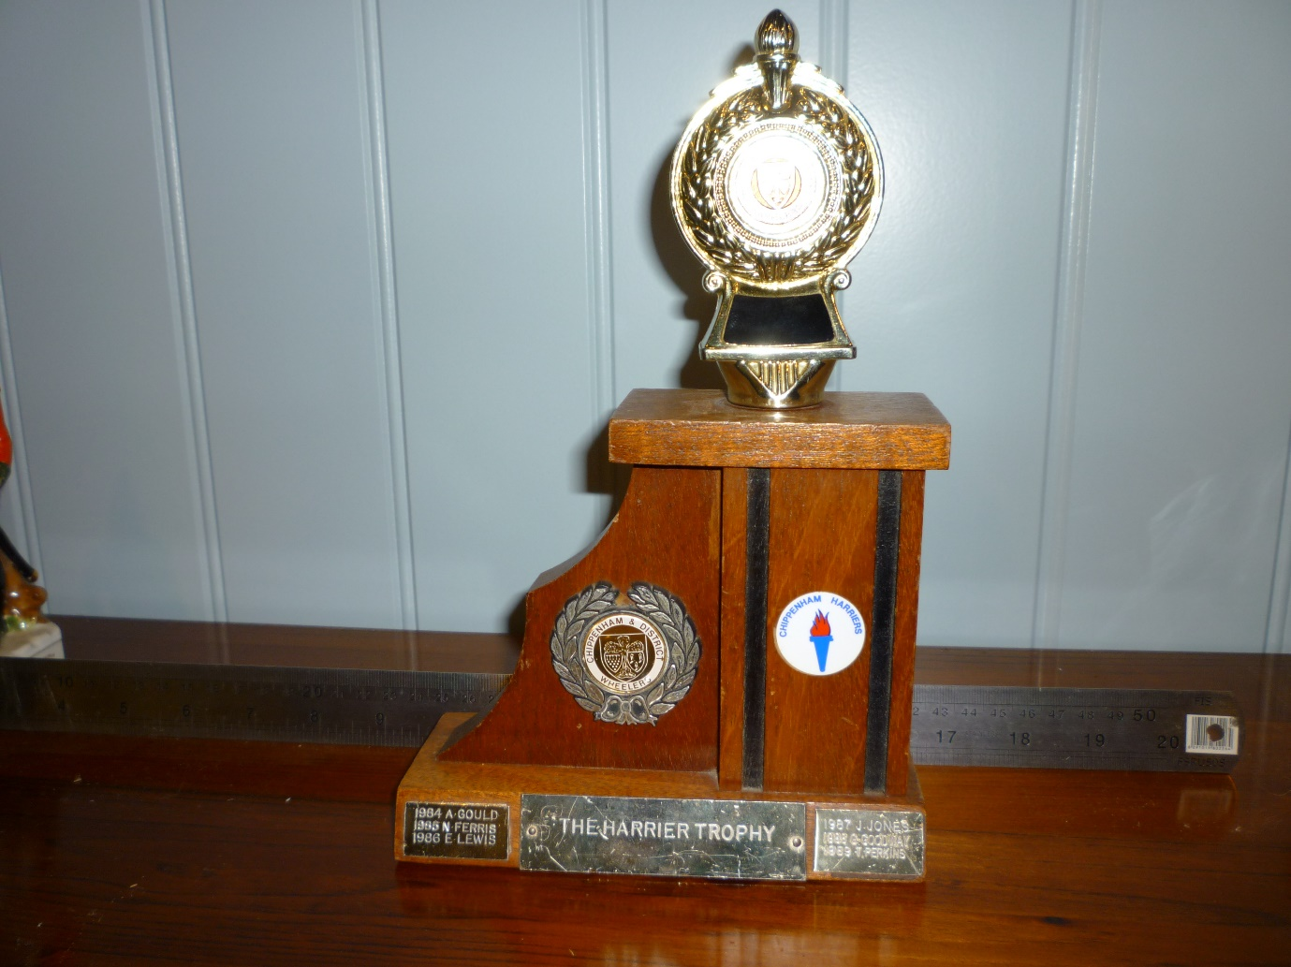
THE HARRIER TROPHY
(FOR EFFORT)
FIRST PRESENTED 1984
Harriers Trophy for Effort. Awarded annually to the member of the Club showing what is considered to be the most determination in cycling related activities without necessarily achieving success. To be decided by discussion and general consensus by the Committee.

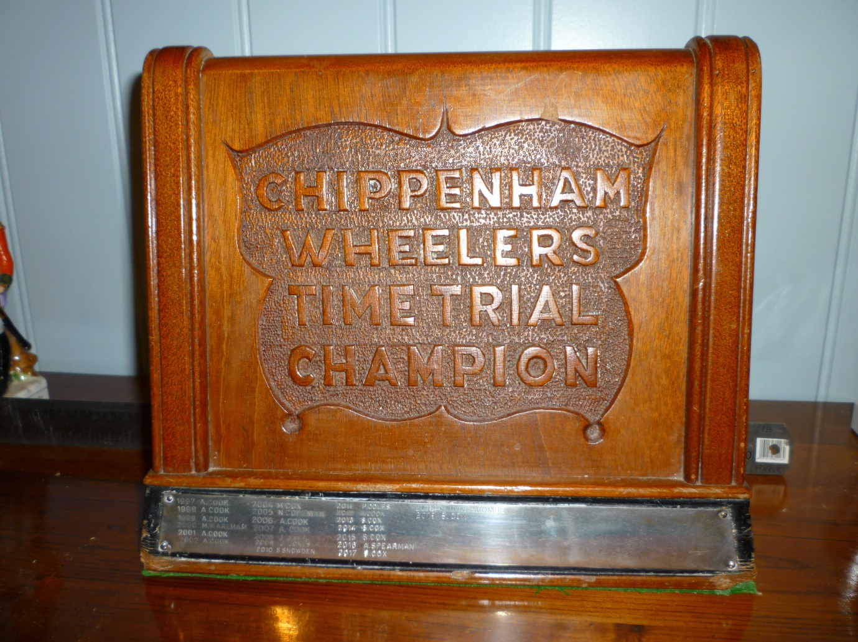
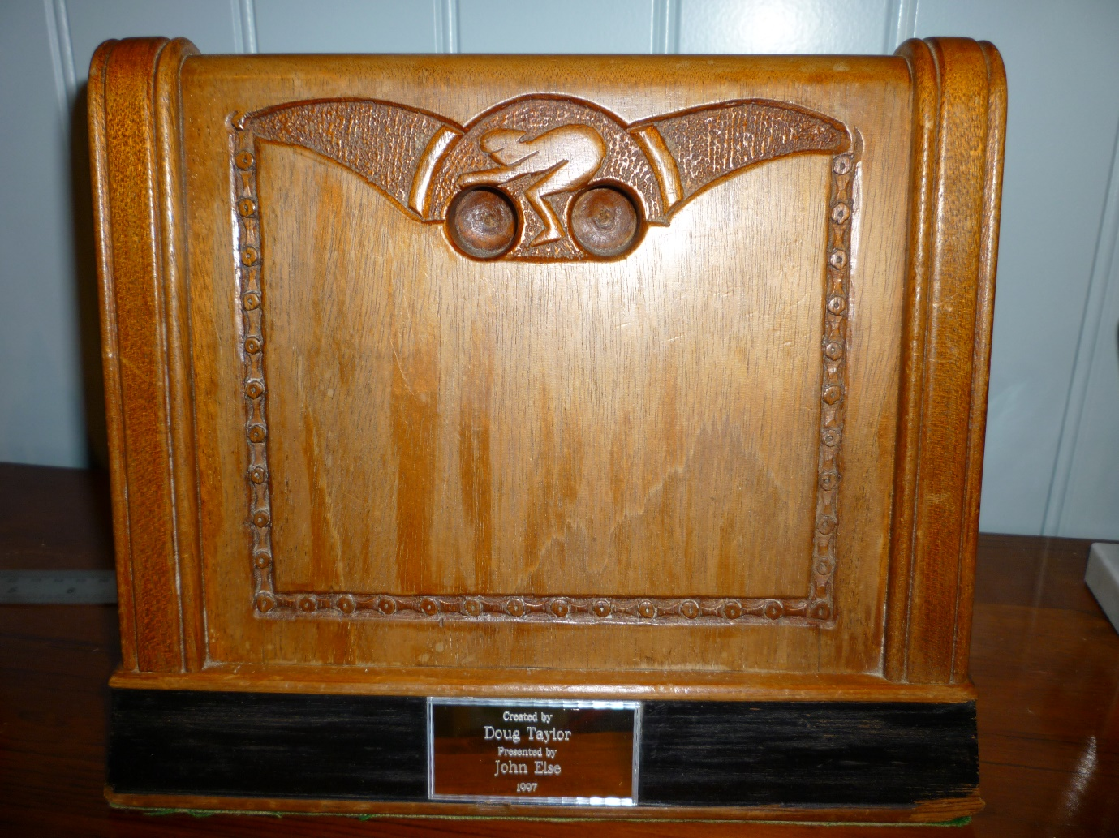
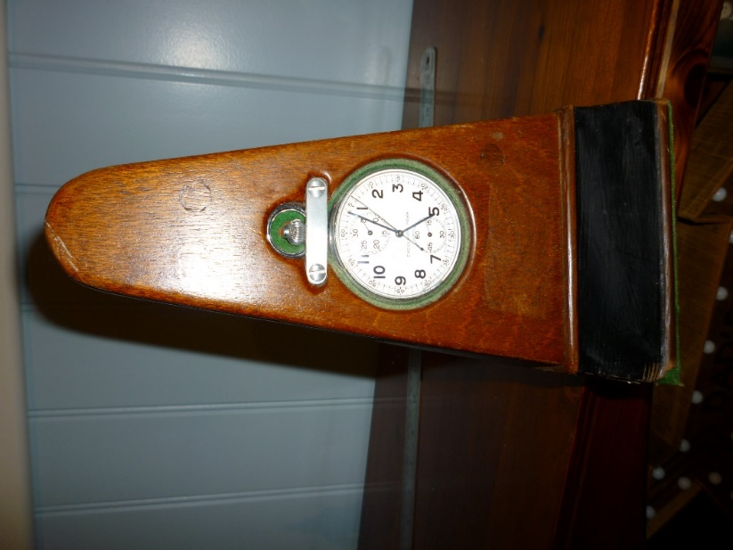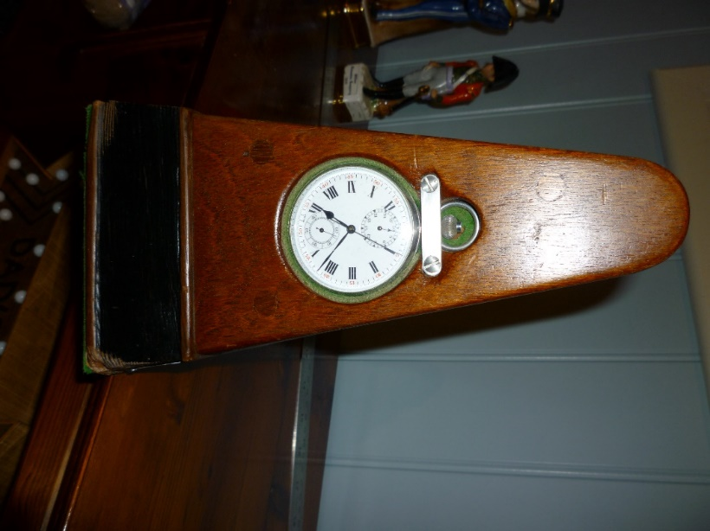
PRESENTED BY JOHN ELSE 1997
CREATED BY DOUG TAYLOR
FIRST AWARDED 1997
CLUB OPEN TIME TRIAL CHAMPIONSHIP
BASED ON 10, 25, 50 AND HARDRIDERS
Time Trial Championship. Awarded to the 1st claim member achieving the lowest points total based on results in nominated events. Points to be awarded relative to the finishing position of Chippenham Wheelers riders in each nominated event. At least one event in each of four categories must be completed for qualification. A tiebreaker should be introduced when required based on a points count back. Events to be nominated by the Club Committee before 1st March in each year. Club events should be omitted. Claims required as in Rule 8.

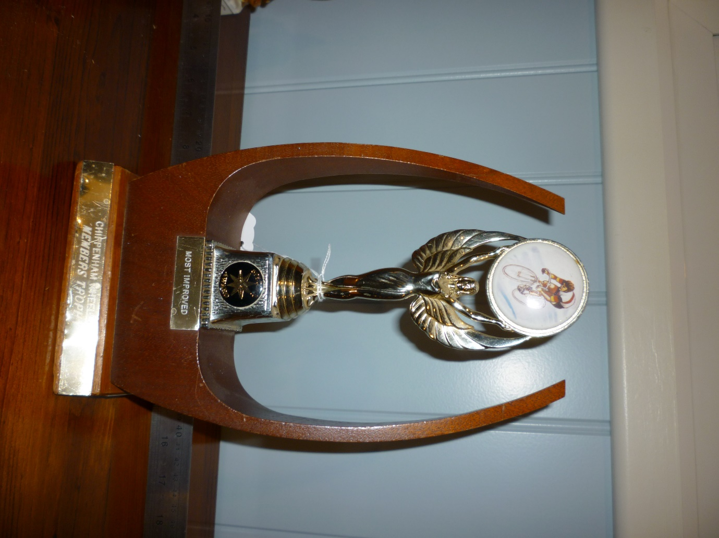
MOST IMPROVED
CHIPPENHAM WHEELERS MEMBERS TROPHY
10 MILE TIME TRIAL SERIES ANNUAL IMPROVED
FIRST PRESENTED 1988
Best Improvement. Awarded to the rider achieving best improvement on previous year’s best performance in Club evening 10 mile Time Trials.
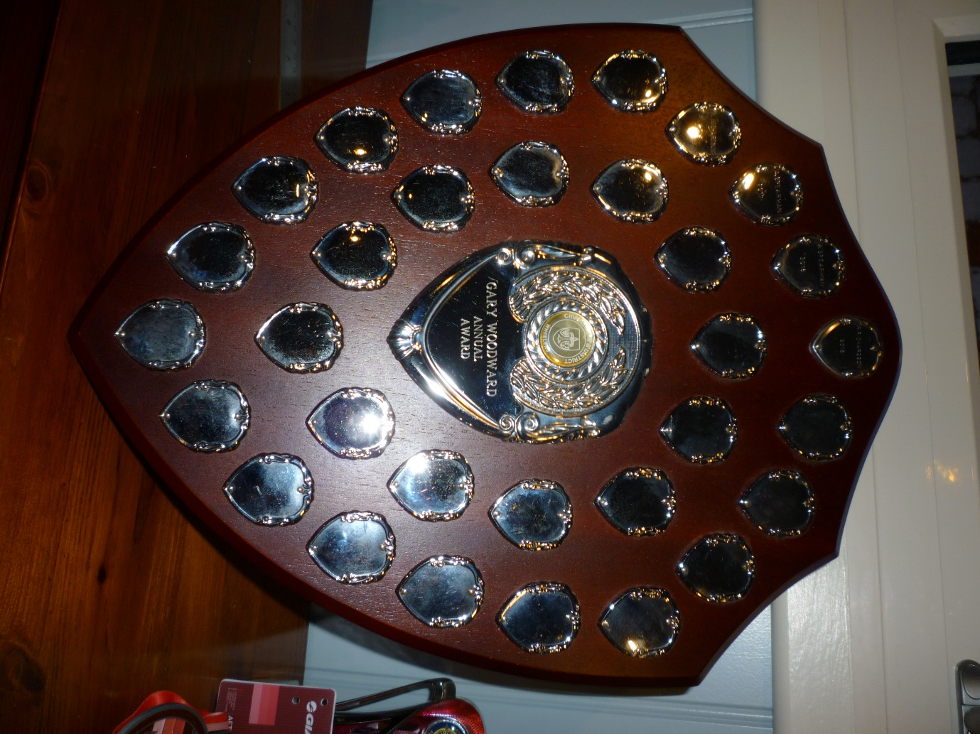
GARY WOODWARD ANNUAL AWARD
CLUB OPEN 25 MILE TIME TRIAL (FOR A WHEELER)
Gary Woodward Shield. Awarded to the fastest club rider in a nominated 25 mile time trial event. (This will usually be the club open 25 mile time trial event.)

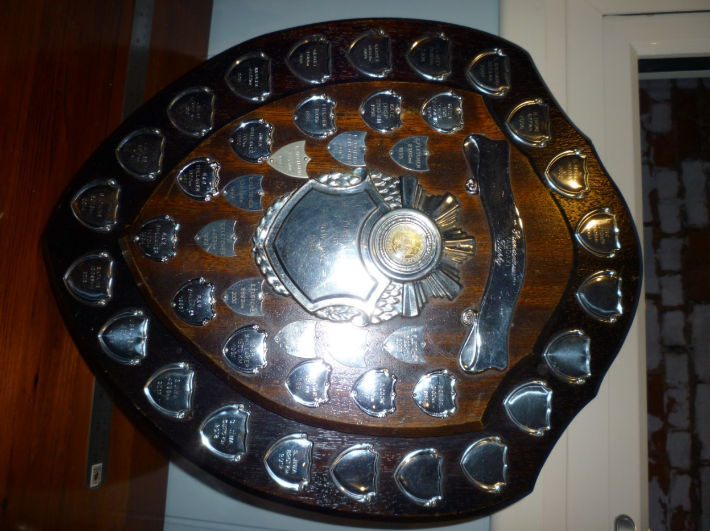
RANDONNEUR (AUDAX) SHIELD
PRESENTED BY R. W. BOND 1984
Audax Shield. Awarded to the 1st claim member amassing the greatest number of kilometres whilst competing in club or open events. All qualifying events must be under AUK regulations. Any distance from 50km upwards, including ‘odd’ distances to qualify. Foreign events also to be included provided they comply with AUK regulations. All events to be supported by completed and homologated brevet cards showing distance. All brevet cards to be handed in by 30th November. Any Open or Club event can qualify provided brevet cards are used. In the event of a tie, the rider with the distance achieved with the least number of events will win the trophy.

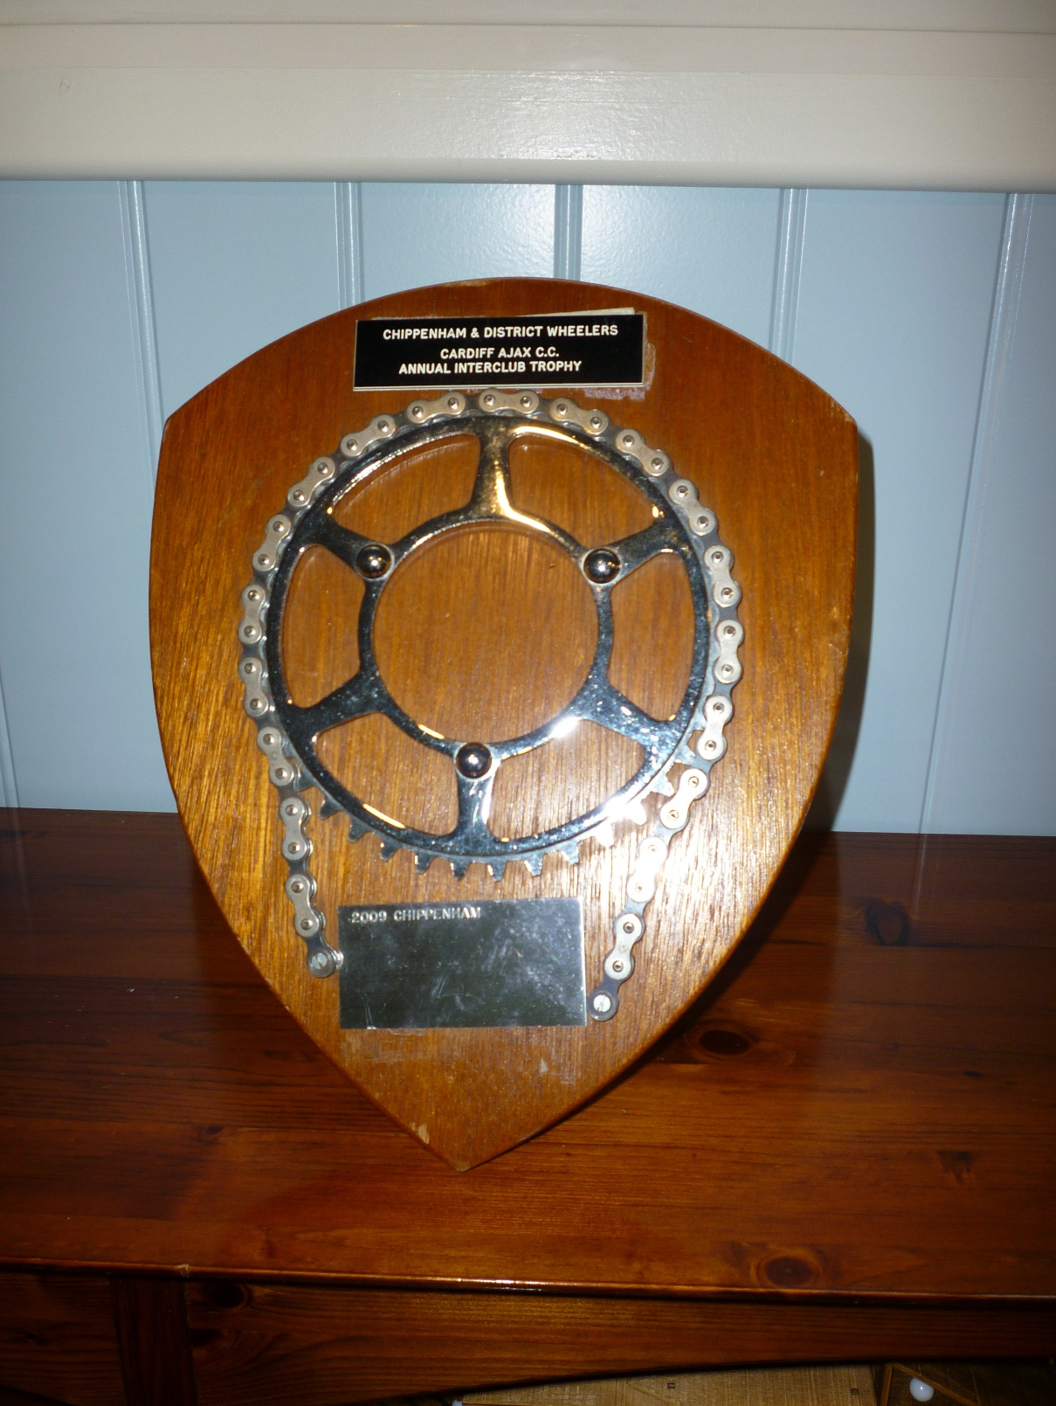
Interclub – with Cardiff Ajax CC
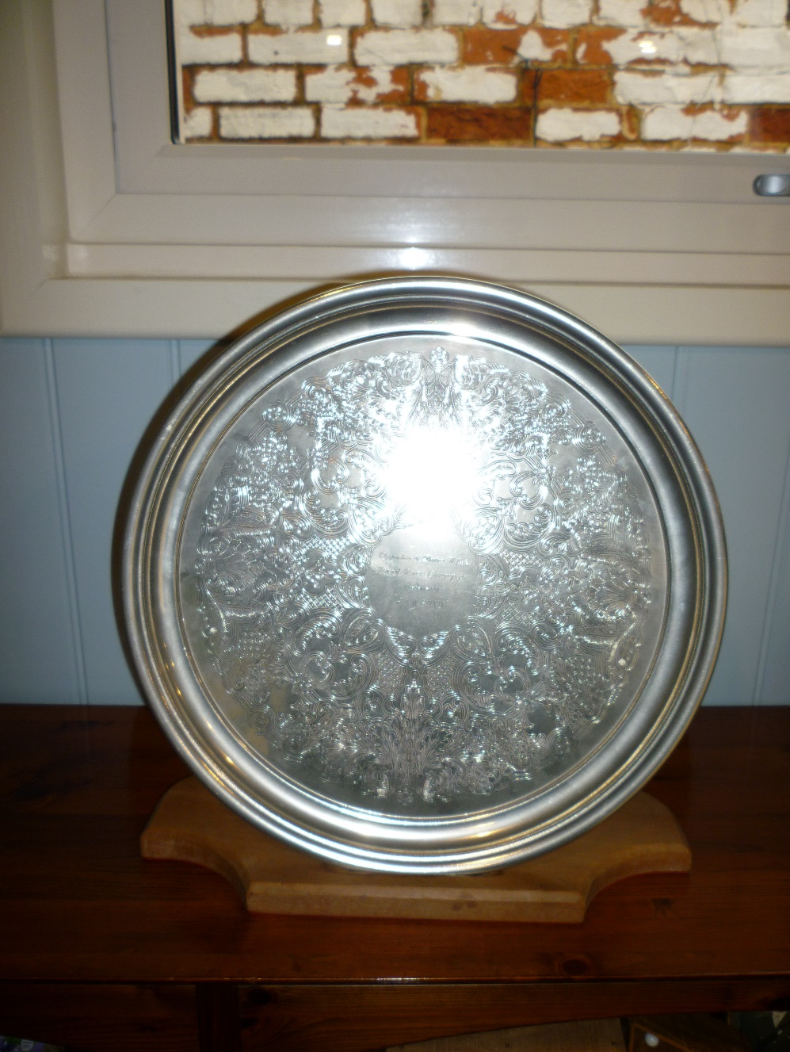
Senior Road Race Champion. To be open to all 1st claim members competing in open road races on a points basis, to be awarded based on the number of British Cycling points obtained. The rider amassing the most points shall be the Road Race Champion, and hold the Road Race Champion Salver for one year.
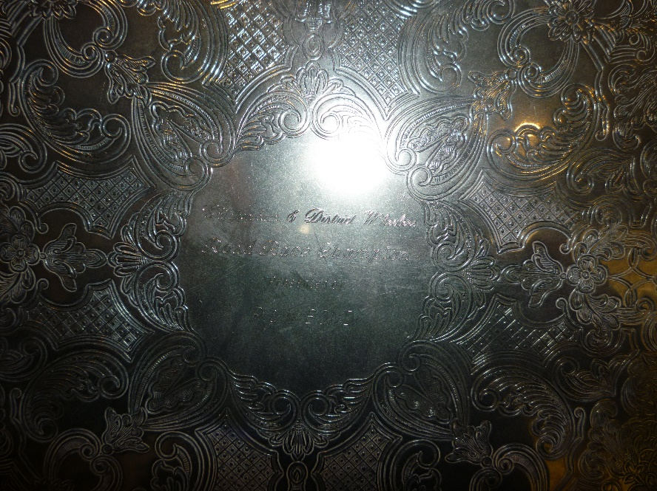
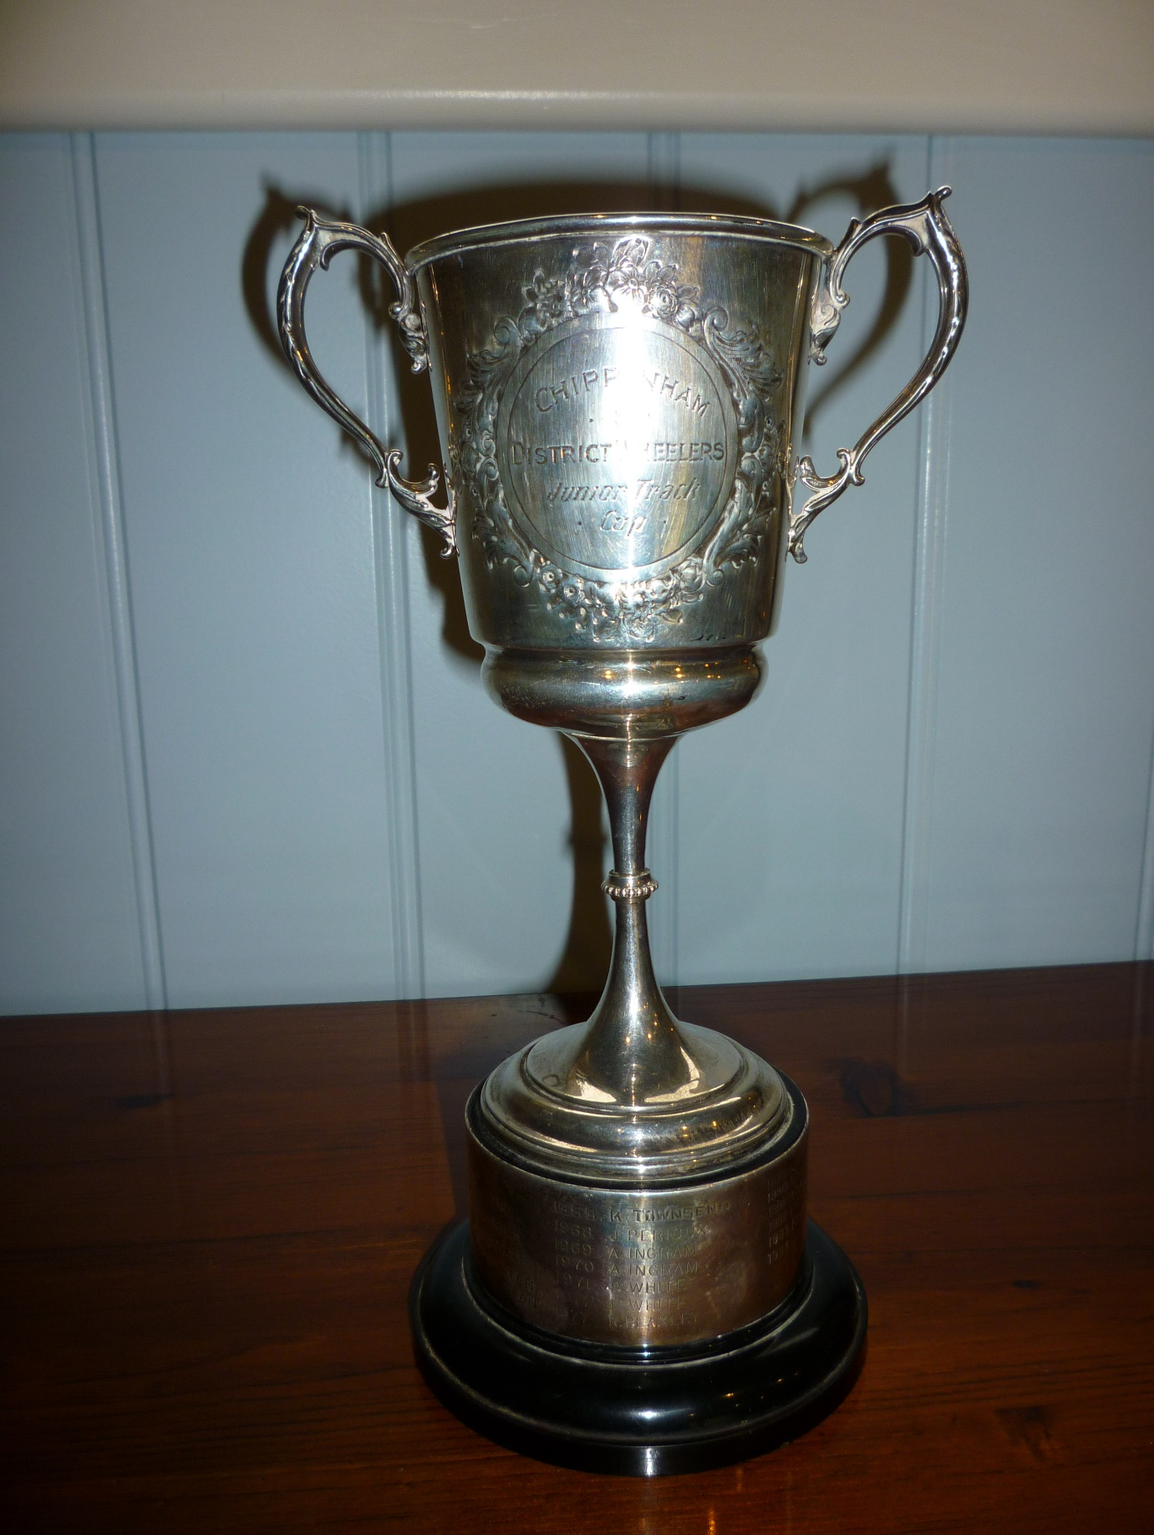
Junior Track Cup. To be awarded to the 1st claim Junior member with conditions as in Rule 38.

First presented 1953

Jack Nunn 10 mile Time Trial Trophies. Awarded to the Senior, Veteran, Lady and Junior 1st claim members recording the fastest aggregate time over 6 rides in the Evening Jack Nunn 10 mile Time Trial Series.
To qualify for this each competitor must marshal or provide assistance for at least one evening or open club event during the season. Claims required as per Rule 8 by competitors with 6 qualifying

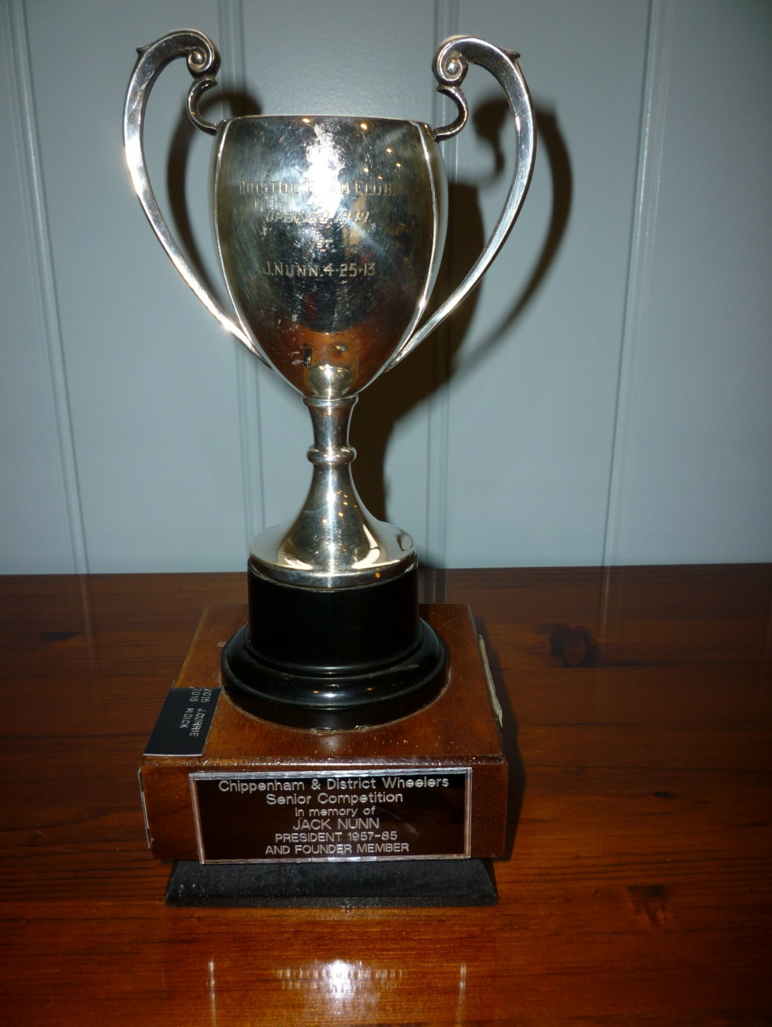
Jack Nunn Senior Trophy
Trophy originally awarded for Bristol Road Club Open 100 – 1949
Awarded to Jack Nunn for a time of 4:25:13

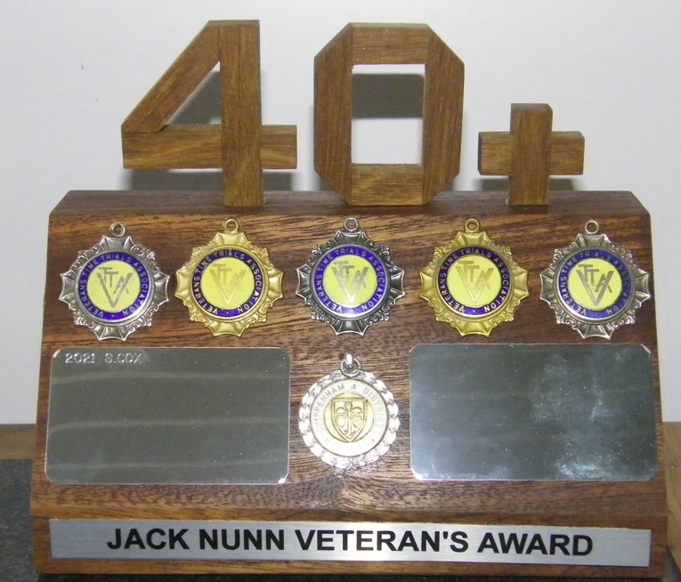
Jack Nunn Veteran Trophy
The tankard originally intended for the Veteran’s Award went missing at the engravers and was never replaced. Mike Edwards was given Jack’s Medals and it was agreed to design a new trophy and finally have a trophy to give the winning Veteran rather than just a keepsake. This new trophy was first awarded in 2021.
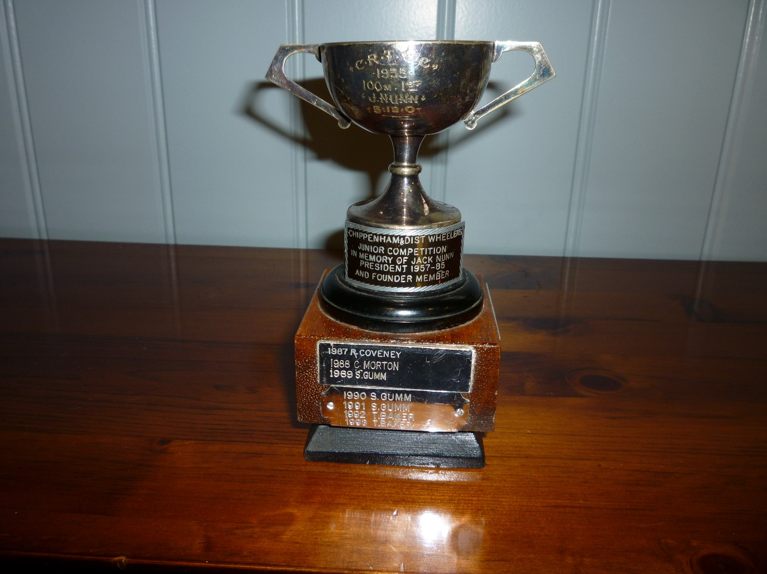
Jack Nunn Junior Trophy
CRT CC
1935
100 Mile 1st
Awarded to Jack Nunn for a time of 5:12:0

The Jack Nunn evening event trophies were given to the club when Jack sadly passed away in 1985. The committee decided that they should be used rather than stored away but the tankard intended for the veterans went missing at the engravers. The owner of the shop was Gary Haskins (Harriers.) who donated two trophies to the club.

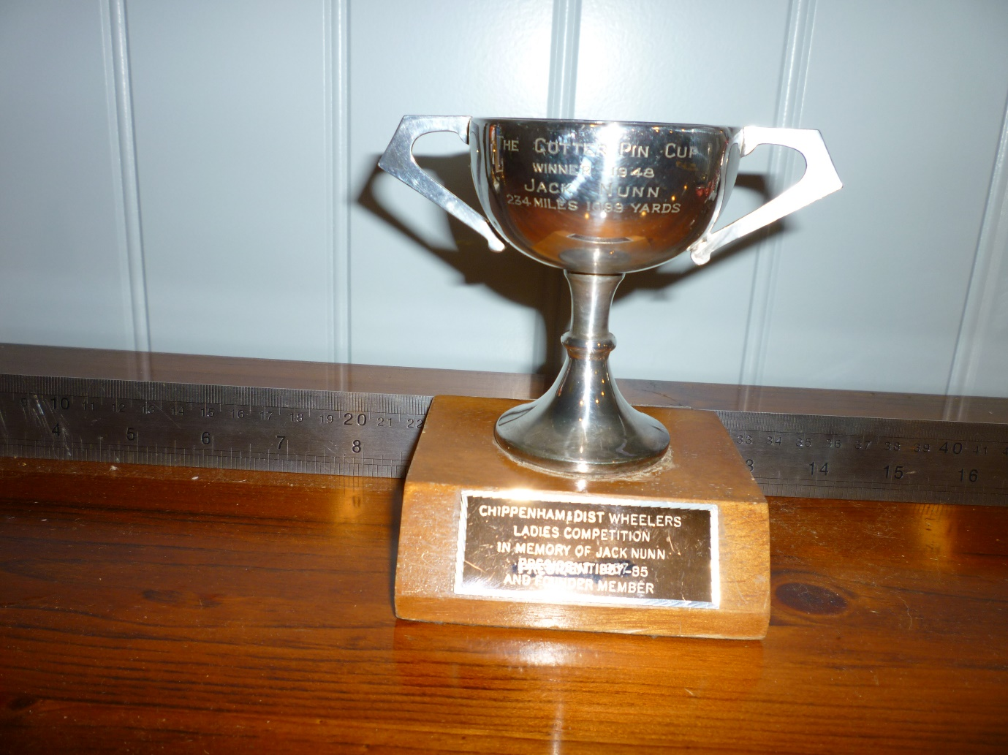
THE COTTER PIN CUP – WINNER 1948
JACK NUNN 234 MILES 1699 YARDS
LADIES COMPETITION
IN MEMORY OF JACK NUNN
PRESIDENT 1957 – 1985 AND FOUNDER MEMBER
FIRST PRESENTED 1993
Club Evening Ladies 5 mile Time Trial Cup. Awarded to the 1st claim Lady amassing the greatest number of points from the evening 5 Mile Time Trial series. Points to be awarded on handicap times, the best six performances to count, with one point awarded for each ride completed.

Not sure why club rules says “5 Mile” when it is for the 10 Mile Series

(There aren’t any trophies for Veteran so assume when awarded is a medal or keepsake trophy)

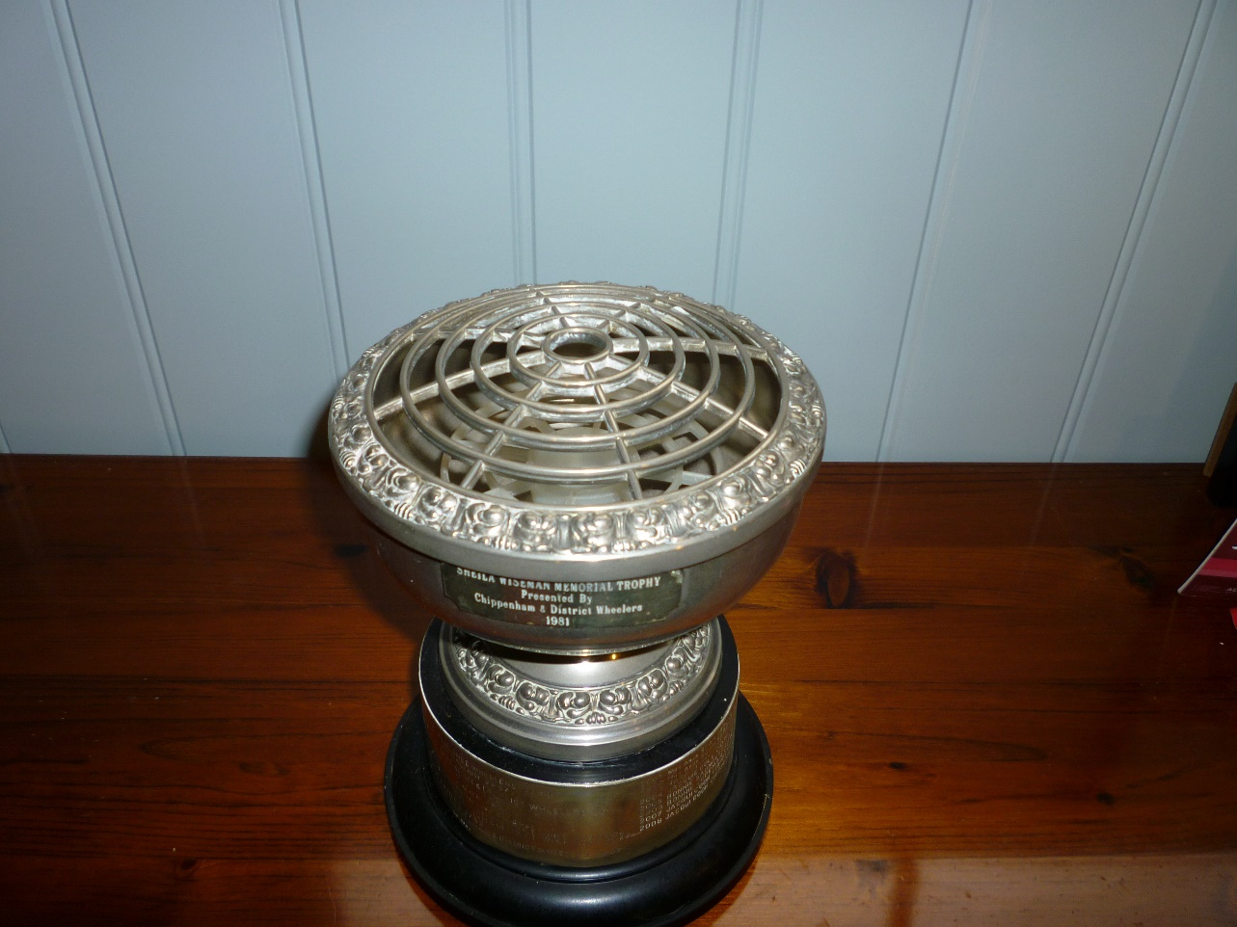

Sheila Wiseman Cup. Awarded to the fastest lady rider (open) in a designated Open 10 Mile Time Trial.
(Note: It is actually a rose bowl)

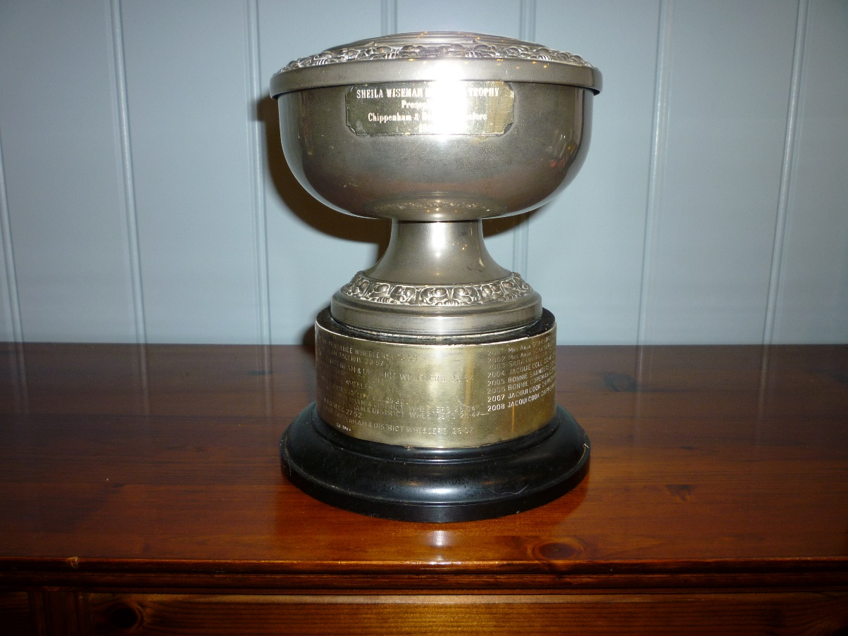
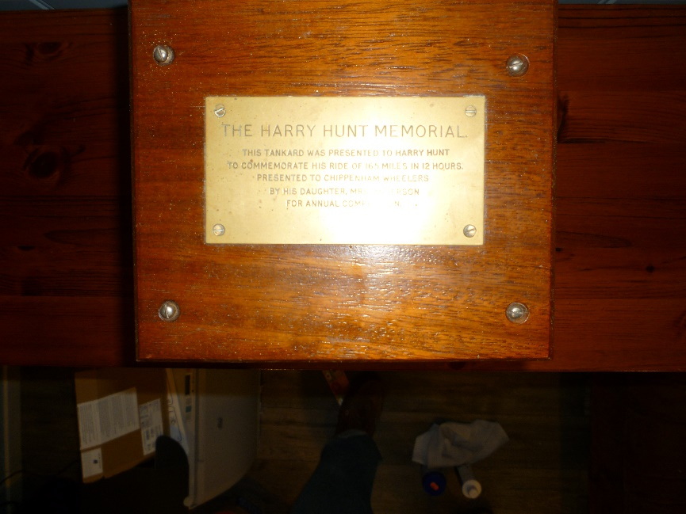
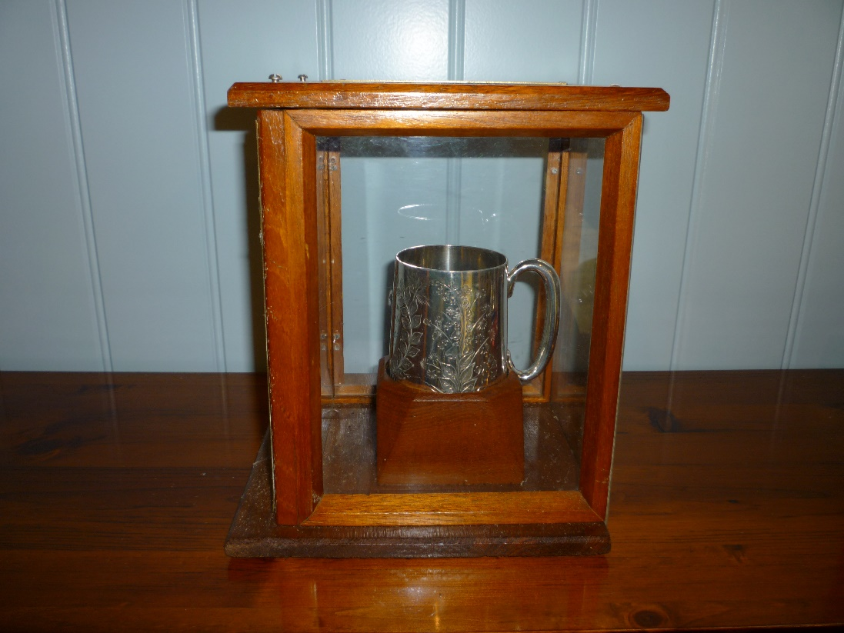

The Harry Hunt Memorial
Awarded to the winner on the Club Open 25 Mile?
Note From Mike Edwards:
The Harry Hunt Trophy was first awarded in 1975 for the Club Open 50 and over the past years the Open 25. To my knowledge this Trophy as been forgotten for at least the last 3 Opens. It was always awarded to the fastest rider.

Harry Hunt was a member of the old Chippenham C.C. and was famous for his long distance riding. In 1895 he rode a”Pneumatic Cycle “ covering 185 miles in 12 hours.
This Trophy (a tankard.) commemorates his achievements, plus we also have several of his medals attached to the President’s Chain. Dick Bond , when Club Secretary obtained these items from a Mrs Anderson, Harry’s Daughter
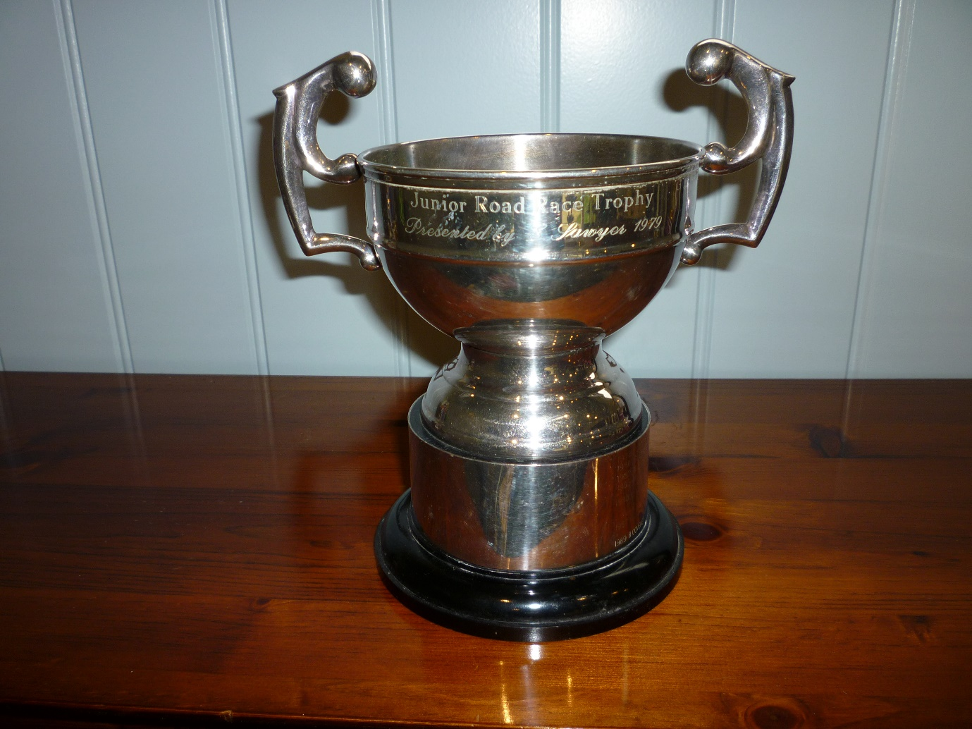
Junior Road Race Trophy
First Presented by E Sawyer 1979
No club rules on presentation

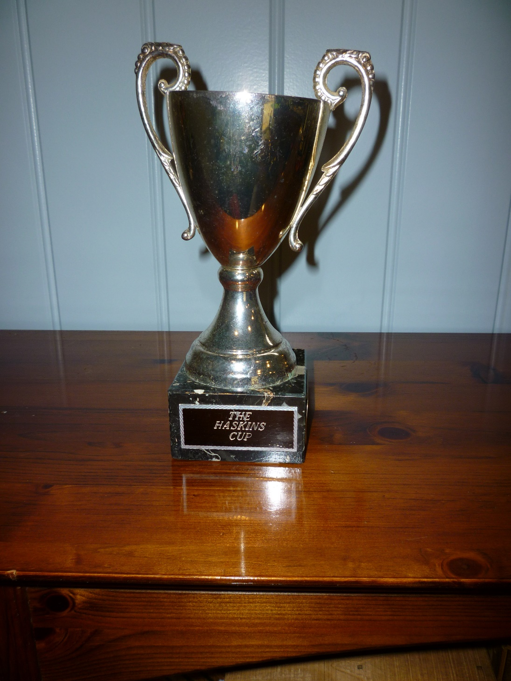
The Haskins Cup
(metal cup, bit scratched)
First awarded 1990
No indication what it is for

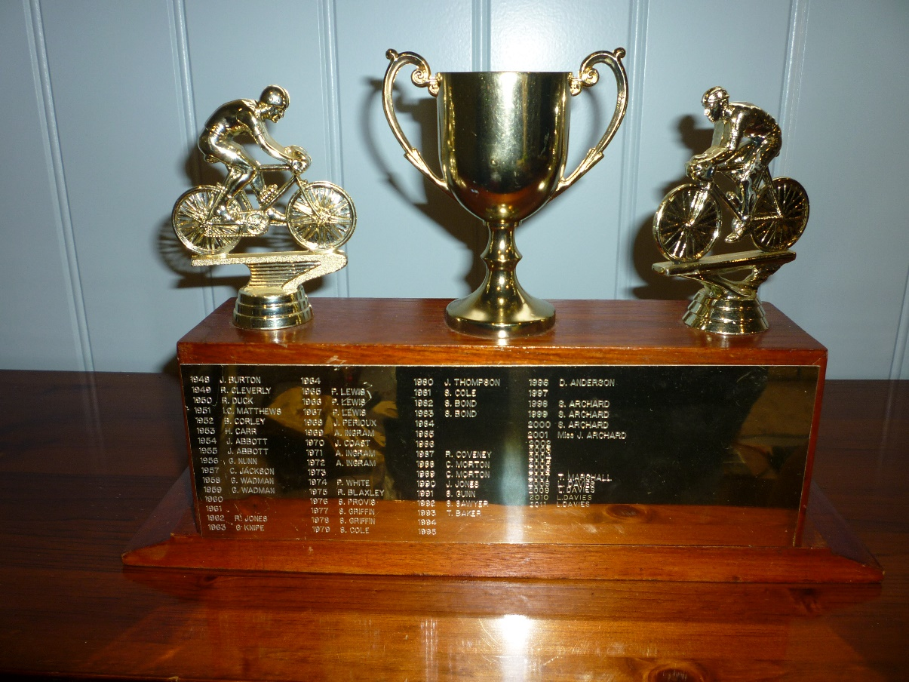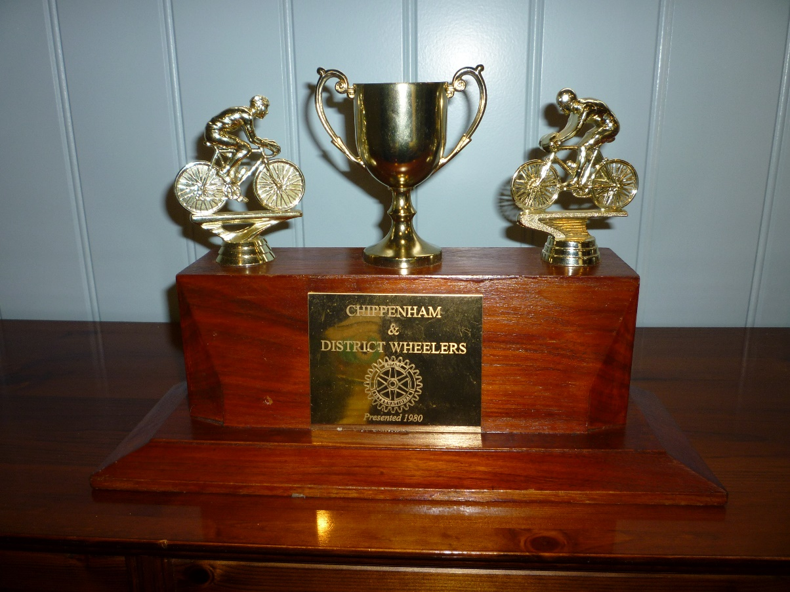
No identifying engraving, last won by Luke Davies in 2011
Although this piece was presented in 1980 the engravings go back to 1948 J. Burton

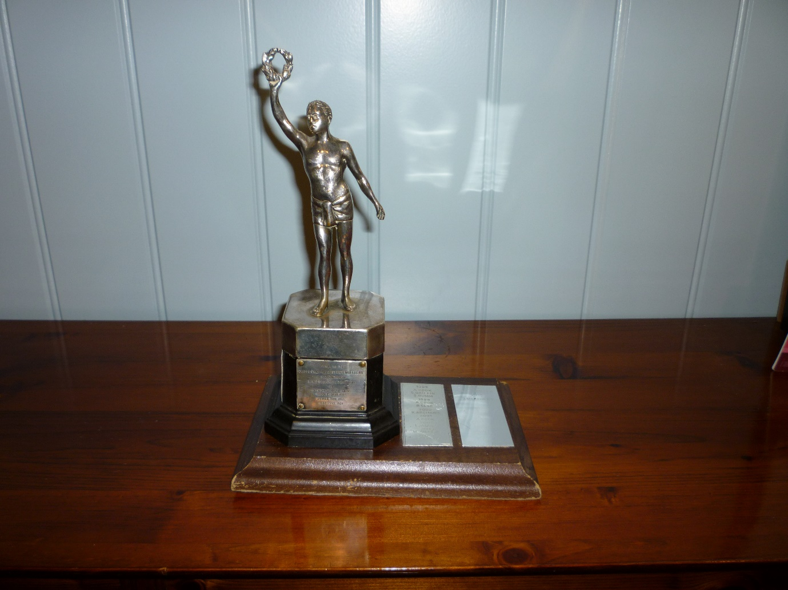
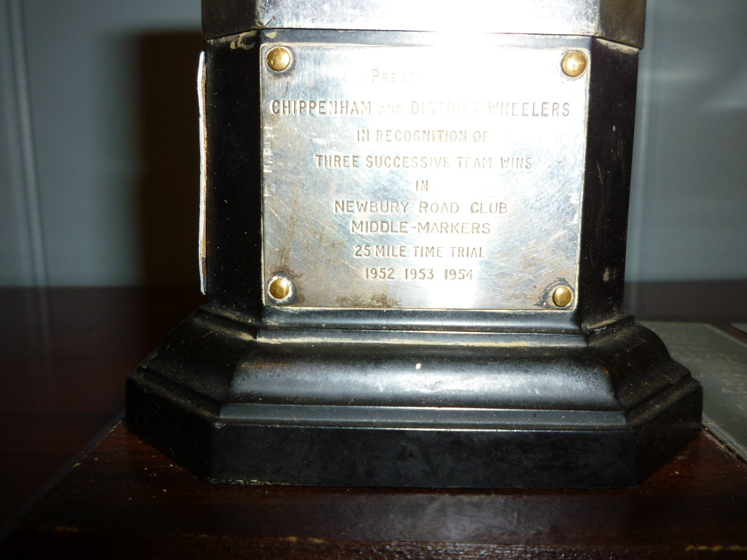
Not identified as to what it is for
Presented in 1954 to club for 3 successive wins in Newbury RC 25 Mile Time Trial and first awarded in 1957
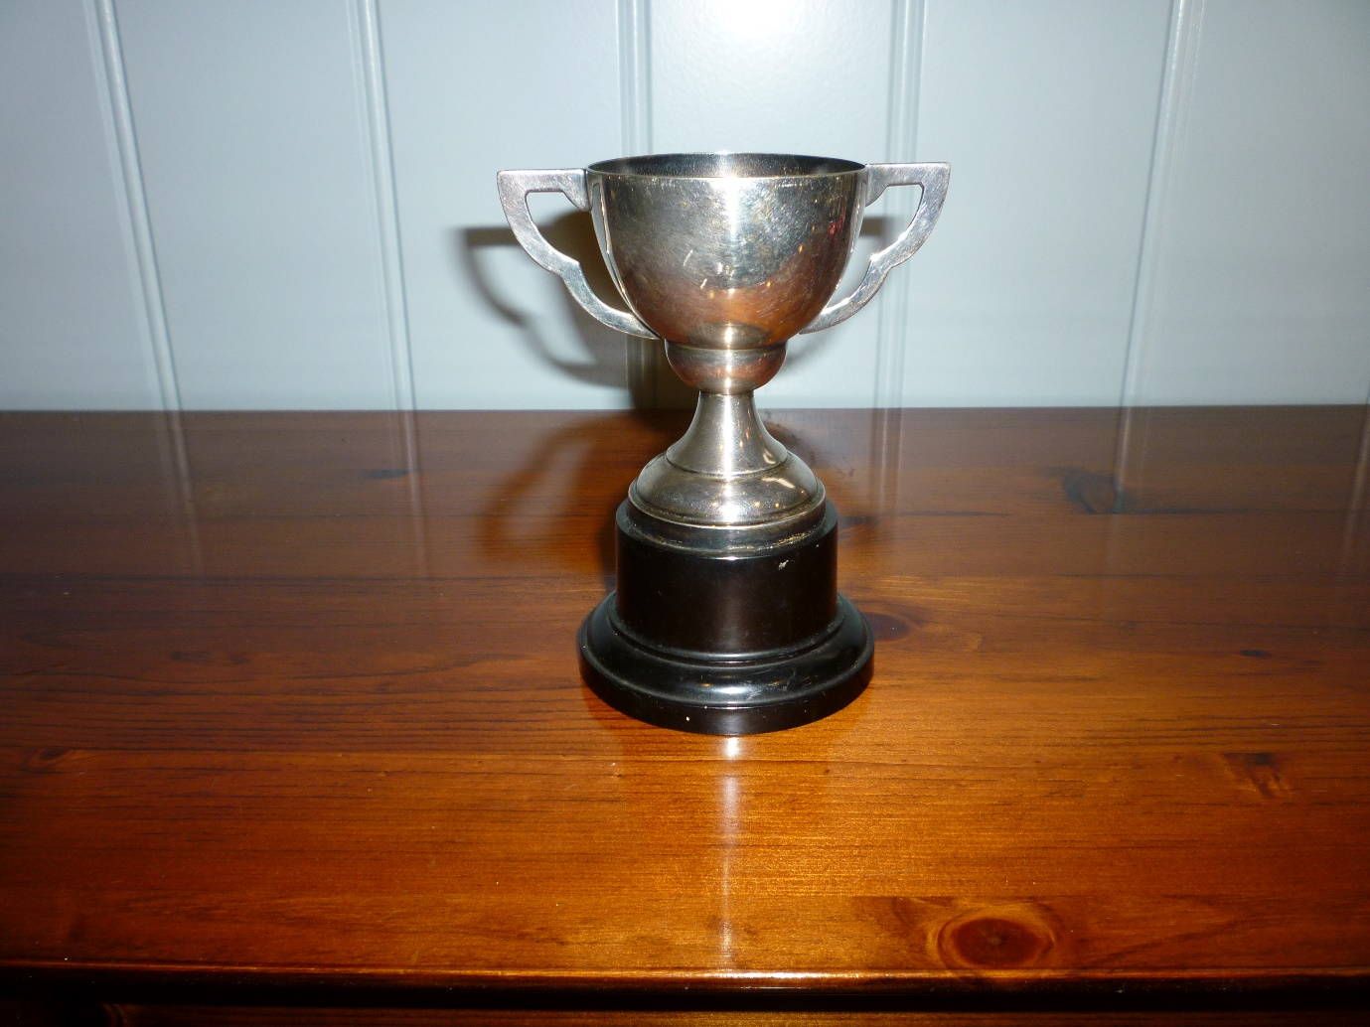
No markings at all on this small trophy

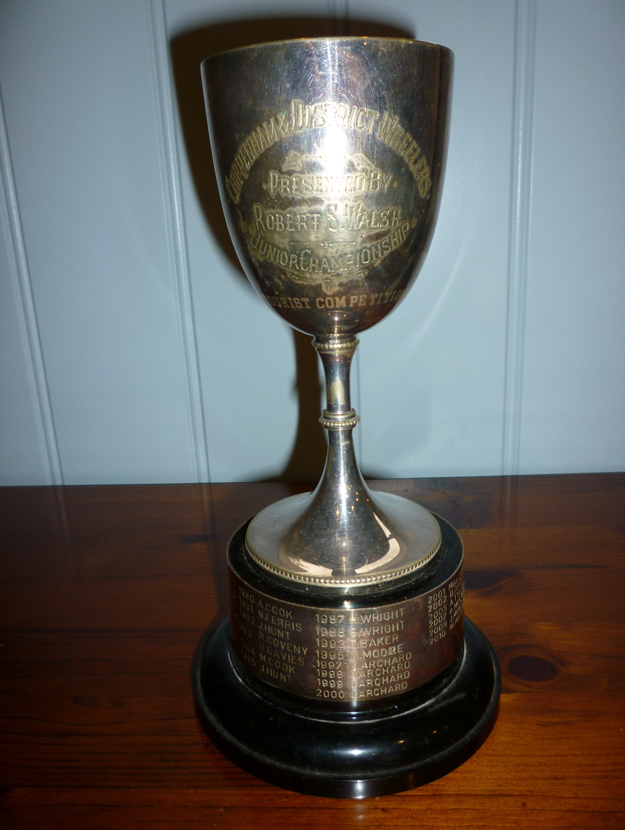

Chippenham & District Wheelers
Presented by S. Walsh
Junior Championship
Tourist Competition
First awarded 1980
Is this the Senior and Junior Touring Trophy?

TROPHIES NOT HELD OR IDENTIFIED

- Track Championship Shield. The 1st claim member who scores the most points in any open, club or club-approved meetings shall be the Track Champion and shall hold the Vintage Shield for one year. The points to be awarded on the following basis: 4 points for 1st place 3 points for 2nd place 2 points for 3rd place 1 point if qualifying for the final. Claims required as in Rule 8 9

- Touring Competition (Senior and Junior). Awarded to winners of the Club Touring Competition. (Is this the Trophy presented by S. Walsh?)

- Junior Time Trial Champion Trophy Best All Rounder (BAR). The first claim Junior member who returns the fastest two performances in 10 mile events and the fastest two performances in 25 mile events calculated in Miles Per Hour, and the average calculated of the resultant speeds, shall be the Junior Time Trial BAR Champion and hold the Junior Championship Trophy for one year. Claims required as in Rule 8.

- Youth Time Trial Champions Cup (BAR). The 1st claim youth member who returns the fastest average speed over any four ‘club’ or ‘open’ 10 mile time trials will be the youth champion and hold the Woodland Cup for one year. Claims required as in Rule 8.

- Youth Evening 10 mile Time Trial Cup. Awarded to the 1st claim Youth member amassing the greatest number of points from the evening 10 mile Time Trial series.

- Club Evening Youth 5 mile Time Trial Cup. Awarded to the 1st claim Youth member amassing the greatest number of points from the evening 5 mile Time Trial series. Points to be awarded on handicap times, the best six performances to count, with one point awarded for each ride completed. To qualify for this each competitor must marshal or provide assistance for at least one evening or open club event during the season. Claims required as per Rule 8 by competitors with 6 qualifying performances.

TROPHY LOCATED BUT NOT CURRENTLY HELD BY CLUB
Jack Nunn Tandem Trophy. Awarded to the tandem pair recording the fastest handicap time in an evening nominated club event. This event is open to 2nd claim members, providing they are partnered by a 1st claim member. Such pairings are not eligible for club records.

Nick Ferris confirmed at Dinner on 25 January 2020 he has it and Kath says she knows where it is

Sheila WISEMAN was a very popular member, joining is most activities club activities together with her husband Les. and two daughters. Sadly she died from cancer and the club’s loss was recognised with the acquisition of the this

Sheila Wiseman was a keen time trial rider regularly representing the club and also enjoying club runs, often accompanied by her husband Les plus their two daughters.
Sadly she died young suffering from some sort of cancer. Her favourite distance was the 10 mile. I don’t know who was responsible for the trophy; so I’ll check out the minute books, but I have a strong feeling that it was the club committee.

The following is taken from the minutes of the October 1981 CDW committee meeting:-
Open 10 mile T.T.
It was proposed that the event in future should be named “The Sheila Wiseman Memorial” and that a suitably inscribed rose bowl be obtained for annual competition, to be awarded to the fastest lady.
Pro: Barbara Else, Sec: Rosemary Provis. Agreed.

At that time Sheila’s husband Les was also a committee member.

Gary Haskins ran a trophy and engraving shop in Chippenham Market place and was an early and enthusiastic Harrier. We used his engraving and medal services for several years. One year he was guest at the Annual Dinner and surprised us by presenting us with the Harriers Trophy.

Gerald Wiltshire hosted our Annual Dinners at St Michael’s Hall in Melksham for many years and was a great admirer of our set up.. He kindly donated the trophy as well as offering special services over the years.
Ted Sawyer ran the long established toy and cycle shop in New Road, in the building now partly occupied by Cycology. He started to give us quite a lot of support and interest and also was a Dinner Guest. As is often the way he presented us with the cup.
(A few years ago, Jonathan of Cycology, told me that the Sawyer family still owned the premises, although son Colin was not interested in pursuing the cycle business.)
Ted Sawyer was a Chippenham cycle dealer, having served his apprenticeship at the Hinder shop. He donated the Rose bowl Trophy for the youth Maud Heath T.T. held for the Chippenham Carnival Week. This was an inter-club event based on teams from two or three other local clubs. The trophy is now awarded for the Castle Combe Youth T.T. s.

Harry Hunt was 19th Century cyclist and Dick Bond manage to acquire this trophy , I think, by creating a link between the earlier Chippenham Club and the later one created in 1932.
John Else joined Wheelers after moving to Chippenham in 1968. I rode for Wheelers then, till 2000, with most of my racing being in time trials , although I also rode cyclo cross and road events.. I was racing secretary for a few years and partly from my background, where results against competitors counted for awards, rather than times I suggested a time trial Championship based on results rather than times, to stand alongside the Road and Track Championships.
As you are aware Stuart (Dick) and Win Bond donated the Road Race Selva and the Audax Shield. They moved from Exeter to Corsham in 1971 to take charge of one of the M.O.D. Storage Units. With their son Mike they were members of the Exeter Wheelers and within weeks they had joined the CDW. Dick became Club Secretary and held it for a record period. It’s thanks to him that we are able to use the Castle Combe circuit for racing and training on Tuesday evenings. His Son Mike was a successful road man, having won the Devon and Cornwall Divisional R.R. Championship twice and also the local Western Division later riding for Chippenham. Dick was shocked to find that we didn’t have a R.R. Trophy with such a successful past history in that field.

The Gerald Cup was presented by Gerald Woodland who owned a catering business at St.Michael’s Hall in Melksham. The annual club dinner was held there for several years.
I believe there is a second trophy that he also donated.

The Mrs.Day cup was donated by the mother of the late Rosemary Provis who was club secretary and dinner organiser for a while. Rosemary’s two young sons raced in the schoolboy events and thus aroused the interest of Rosemary’s mother.

The Jack Nunn evening event trophies were given to the club when Jack sadly passed away in 1985. The committee decided that they should be used rather than stored away but the tankard intended for the veterans went missing at the engravers. The owner of the shop was Gary Haskins (Harriers.) who donated two trophies to the club.
Jack’s medals were given to me and it could be possible to design a trophy incorporating some of his Vet’s awards to replace the missing tankard.

The Hillclimb Tankard was presented by a Mrs.Roberts who was the mother of Harry Roberts who was a member in the 1940s and club Secretary during the mid 1950s. Harry was a larger than Life Character which reflected in his post of Union Rep: while working at Westinghouse Signals. He eventually became a cycle mechanic working for Fred Baker cycles in Bristol and then moved to Ayr in Scotland to work for Jock Fairburn Cycles. In 1964 while home on holiday he was sadly killed in a road accident on the Warminster to Westbury road.

A.R. Hinder was the first president (1934) of the reformed Chippenham cycling club and owned a cycle shop next to the Railway Arches in New Road Chippenham.

The Nixon Cup was presented by the then Mayor of Chippenham who was an ex Liverpool footballer before moving to the town.

David Evans was a School teacher at the Sheldon School in Chippenham during the middle to late 1960s. He formed a cycling club for his pupils and took them out on rides and even organised a touring holiday in Holland. Jack Nunn and myself helped after classes giving the lads talks, film shows and we even organised a afternoon of grass track and fun rides. He awarded the trophies when he moved to Dursley (1968/69) and the Couriers as they were known joined the Wheelers. No one else in the school would take over the responsibility. Dai became one of the founder members of the Dursley Road Club.

The Gary Woodward Trophy was presented by his wife Jackie and his son Dwain after Gary had sadly died while out on his bike. Has you know Gary was one of the most successful riders in the district and was rated as a “top 10” rider for the 100 mile T.T. in the country.

The Ted Barlow Trophy like Gary’s was awarded by his widow Muriel Ted having passed away within a few weeks of Gary’s passing. Ted joined the Wheelers at the beginning of 1951 and became a hard working club official and credit is due to him for the survival of the club through the early 1960s when cycling was suffering in popularity. He also served on the local RTTC West District committee and was their representative at the RTTC AGM s held in London in those days.

The Harry Hunt Tankard was given to the club by his daughter Mrs.Anderson after the research carried out by Dick Bond. Harry was a member of the Chippenham C.C.in the late 1880s and had broken the 12 hour record on several of his rides. His best was October 1896 with a mileage of 182. Several of his silver medals are part of the CDW President’s Chain.

The two watches on the Wooden T.T. Trophy are the time pieces used by the club timekeepers before the digital era.

The 10 Mile T.T. Cup was presented by Sheila because there was no Club Championship at that distance. Her mother Mrs.Barlow donated the Veterans BAR Cup.
Sheila and her mother became club members in 1956 and at the end of the year became joint social secretaries. Sheila served on the committee for several years including the post of racing secretary. In 1958 Sheila became Ladies BAR Champion, but general club runs and YHA weekends were more to her liking.

The 50 mile Cup in my name was a committee suggestion and thus paid for by the club to commemorate my fifty year’s membership.

Did you know that the.

