UC861: | (Evening 10 course)
Course Record:
Set by Jeff Jones 12 August 2009 with a time of 21:12
Sign on in Queens Field, Sutton Lane.

Start at Sutton Benger on B4069, opposite junction Sutton Lane. Continue through Christian Malford and on to Swallet Gate (SU990808) where turn left. Continue over bridge crossing M4 to junction to Dauntsey where turn right. Continue through Dauntsey to Little Somerford where turn left towards Great Somerford. Continue through Great Somerford and continue on to finish opposite junction with Upper Seagry Road at SU949801.
Map
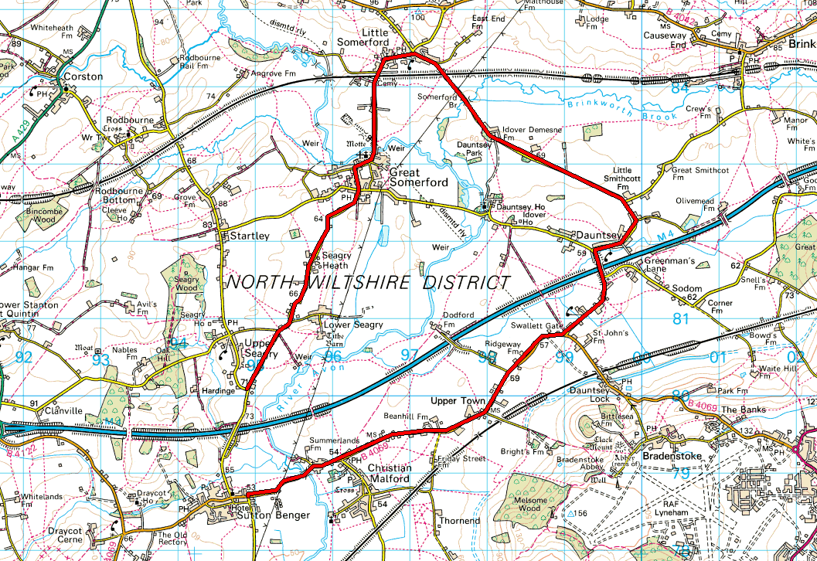
Your Course Notes (Personal Best, etc..)

UC862: | (Club ‘25’)
Sign on at ‘Wavin/Parsonage Way Industrial Estate’ (see Guidelines on Page 16)

Start on the B4069 between the junctions of Hill Corner Road and Parsonage Way on B4069 through Kington Langley to Sutton Benger *. Continue to Swallet Gate (SU990808) where turn left. Continue over M4 bridge to junction to Dauntsey where turn right. Continue through Dauntsey to Little Somerford where turn left. Continue through Great Somerford to Sutton Benger. At the junction with the B4069 turn left and complete the circuit from * to finish opposite junction with access road to disused pit (SU945792).
Map
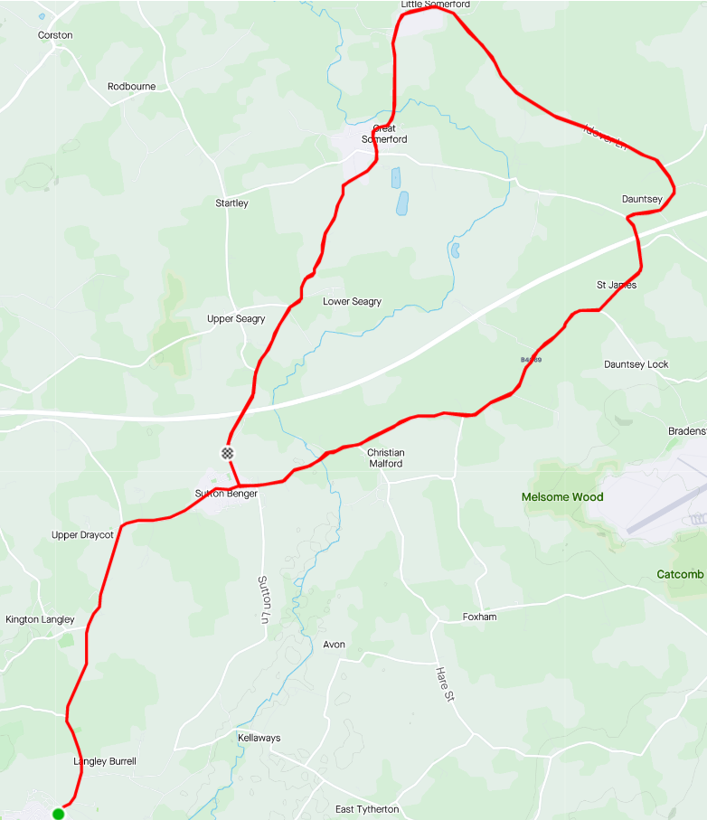
https://www.strava.com/activities/3834915241

Your Course Notes (Personal Best, etc..)

UC863: | (Sporting ‘15’ Lyneham & back B4069)
Course Record:

Sign on in Queens Field, Sutton Lane. (4 miles to start) (see Guidelines on Page 16)

Start on the B4069 in double lay bys in Kington Langley. Follow B4069 to Lyneham roundabout, junction B4069/A3012. Circle roundabout and retrace on B4069 to finish opposite start.
Map
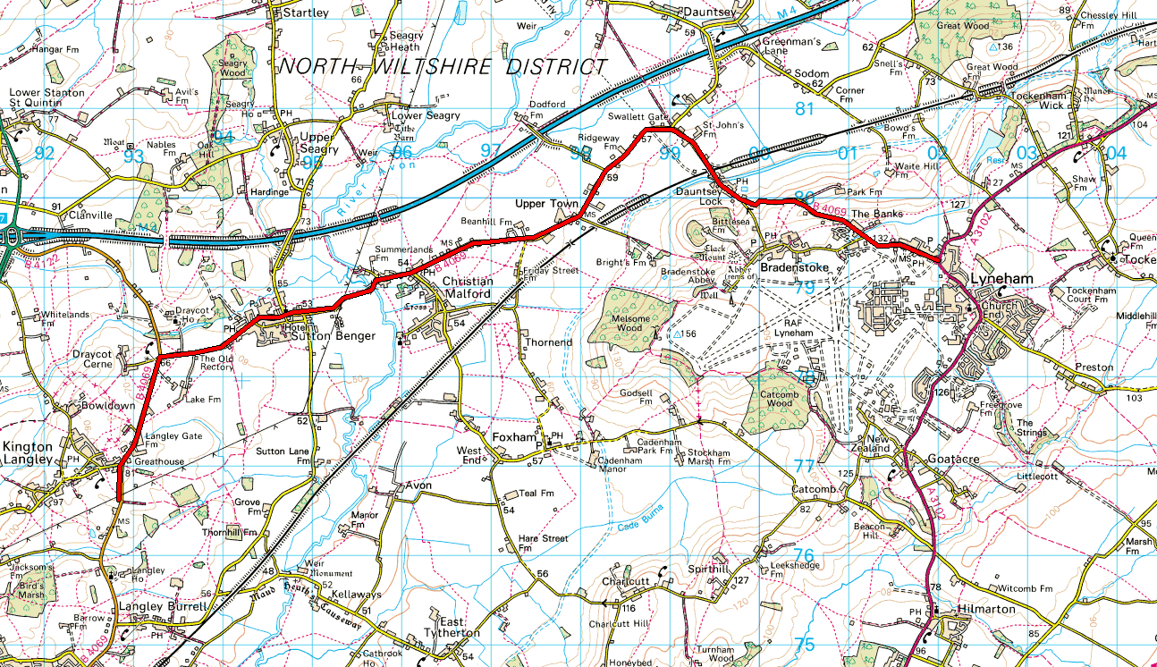

Your Course Notes (Personal Best, etc..)

UC863S: | (Lyneham Banks Sporting 10.6)
Course Record:

Sign on in Queens Field, Sutton Lane.

Sutton Benger to Lyneham & Back. (Shortened version of the UC863).
New course code for UC863S clashes with original UC863.

Map
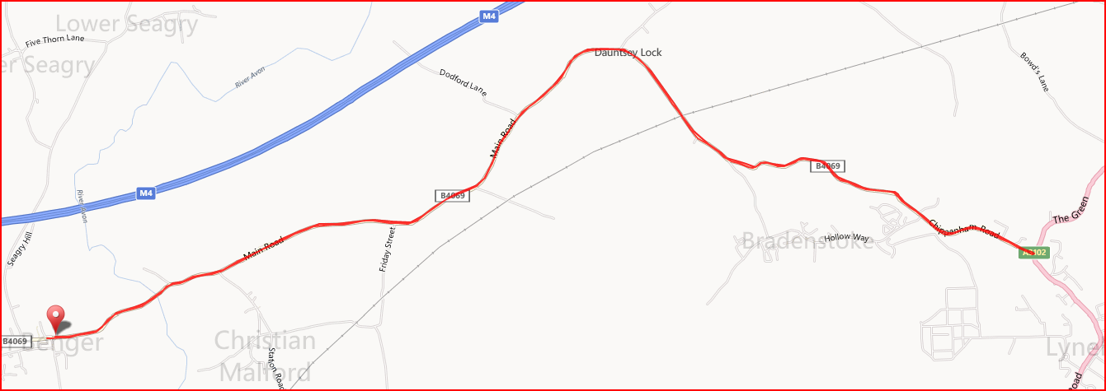

Your Course Notes (Personal Best, etc..)
https://www.strava.com/segments/3923418

U861/50 - UC864 | (Club ‘50’)
Course Record:

Sign on in Queens Field, Sutton Lane. (4 miles to start)

Start at the junction of Idover Lane, Dauntsey and complete four circuits of ‘10’ course. Continue to Finish opposite junction with access road to disused pit (SU945792).
(May be held by West DC as U864)
Map
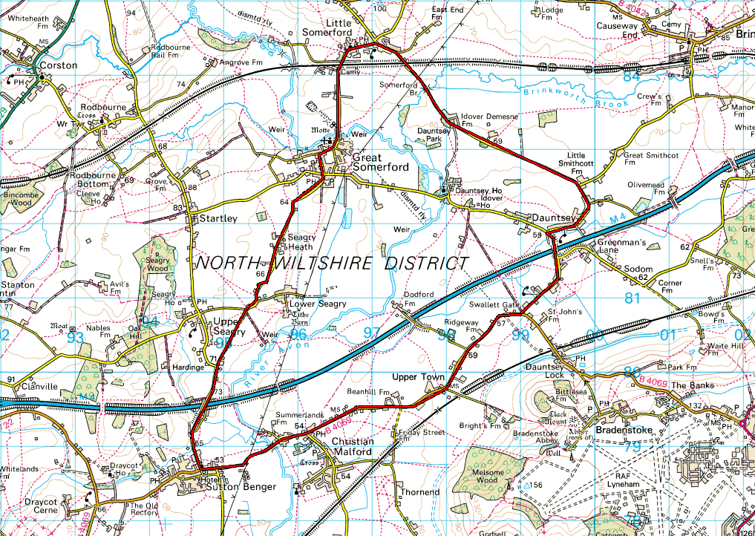

Your Course Notes (Personal Best, etc..)
https://www.strava.com/segments/4607346

U865: | (Sporting 10)
Course Record:

Sign on in Queens Field, Sutton Lane.

Stars Sutton Benger, finishes Upper Seagry

Start in opening 200m north of Vintage PH. Cross motorway, and pass through Great Somerford to Little Somerford, where left to junction with B4042, where left to Malmesbury ‘Hospital’ roundabout, where left onto A429 for 1km, then turn left (Grange Lane) and through Startley to finish at Upper Seagry adjacent to village hall.

Map
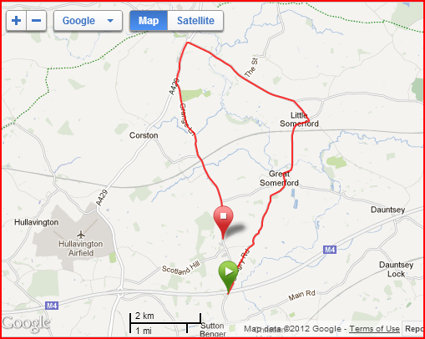

Your Course Notes (Personal Best, etc..)

U866: | (10 Mile Time Trial – The “Q” Course)
Course Record:
23:07 Simon Cox 15 August 2012
Sign on in Queens Field, Sutton Lane.

UC866: Starts Sutton Benger, finishes junction Dauntsey Lane/Green Lane
START (G.R. 950787) in High Street, Sutton Benger. Start is opposite junction with B4069.
Go East on B4069 (direction of Lyneham). Continue towards turn at Swallet Gatet. Turn left into Church Lane and 100m after crossing M4 Motorway bridge turn right across road into The Green. Continue North West to Little Somerford along The Idover Lane. Turn left by bus shelter in Little Somerford. Continue towards Great Somerford. In Great Somerford turn left into Dauntsey Road. Continue to finish 10m before junction of Church Lane and the Green at Dauntsey.

Map
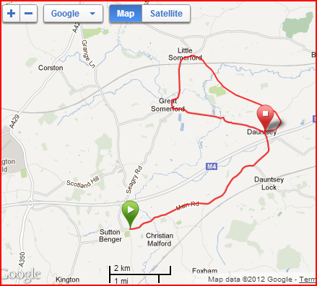

Your Course Notes (Personal Best, etc..)
https://www.strava.com/activities/43853692
Avoids Seagry Road

UC867: | (The ‘P’ course)
Course Record:

Sign on in Queens Field, Sutton Lane.

Start at junction Upper Seagry Road (SU949801) to Great Somerford. Turn right to Dauntsey. At Dauntsey junction (SU994819) turn left. Continue through Dauntsey to Little Somerford, turn left towards Great Somerford. Continue through Great Somerford and finish 50 metres past junction with Upper Seagry Road.
Map

Your Course Notes (Personal Best, etc..)
https://www.strava.com/segments/17947191
Avoids B4069 Sutton Benger to Dauntsey

U83: | (Sporting 24)
Course Record:

Sign on in Queens Field, Sutton Lane (2 miles to start)

Start on B4069 in double lay bys in Kington Langley. Proceed north through Sutton Benger and Dauntsey Lock to Lyneham where left at roundabout, onto A3102 to Wootten Bassett, where left into Whitehill Lane. After 1 ½ miles approx turn right under motorway and ascend Callow Hill towards Swindon-Malmesbury main road. At crossroads left onto B4042 towards Malmesbury. At Malmesbury roundabout take first exit (left) towards Chippenham. Take next left into Grange Lane, passing through Startley to finish adjacent to Upper Seagry Village Hall
Map
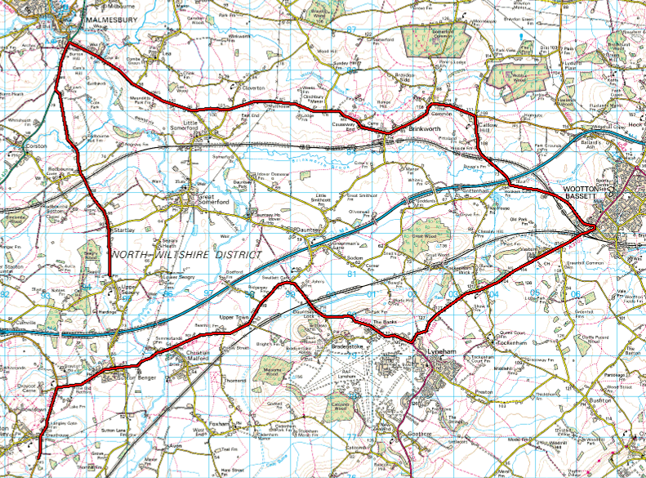

Your Course Notes (Personal Best, etc..)

UC 865: | (Sporting 10)
Course Record:

Sign on in Queens Field, Sutton Lane

Start in opening 200m north of Vintage PH. Cross motorway, and pass through Great Somerford to Little Somerford, where left to junction with B4042, where left to Malmesbury ‘Hospital’ roundabout, where left onto A429 for 1km, then turn left (Grange Lane) and through Startley to finish at Upper Seagry adjacent to village hall.

Map
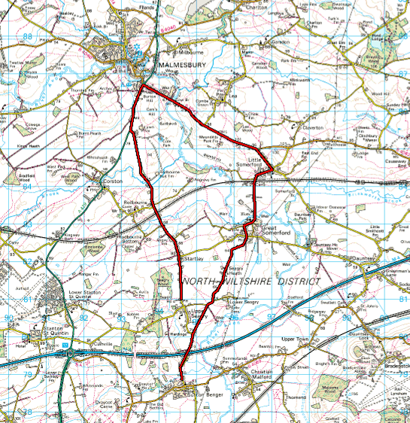

Your Course Notes (Personal Best, etc..

UC861 Short Course | 8 miles
Course Record:

Sign on in Queens Field, Sutton Lane

Start Sutton Benger
Finish at Great Somerford.

Map
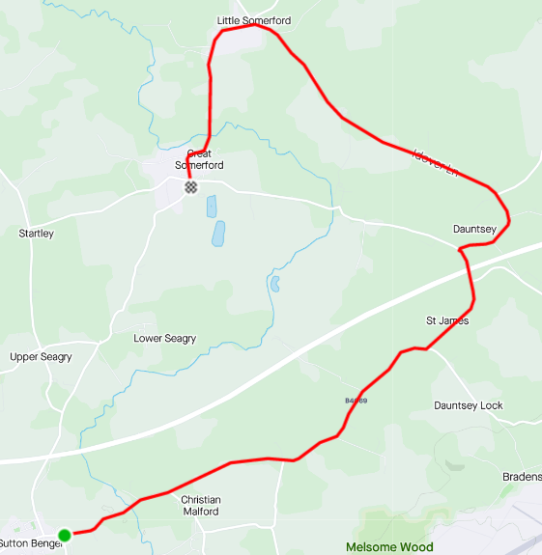

Your Course Notes (Personal Best, etc..
https://www.strava.com/activities/46625305
Avoids Seagry Road

UC867 Short Course: | 5 Miles
Course Record:

Sign on in Queens Field, Sutton Lane

Start Dauntsey turn after M4 bridge
Finish on Seagry Road.

Map
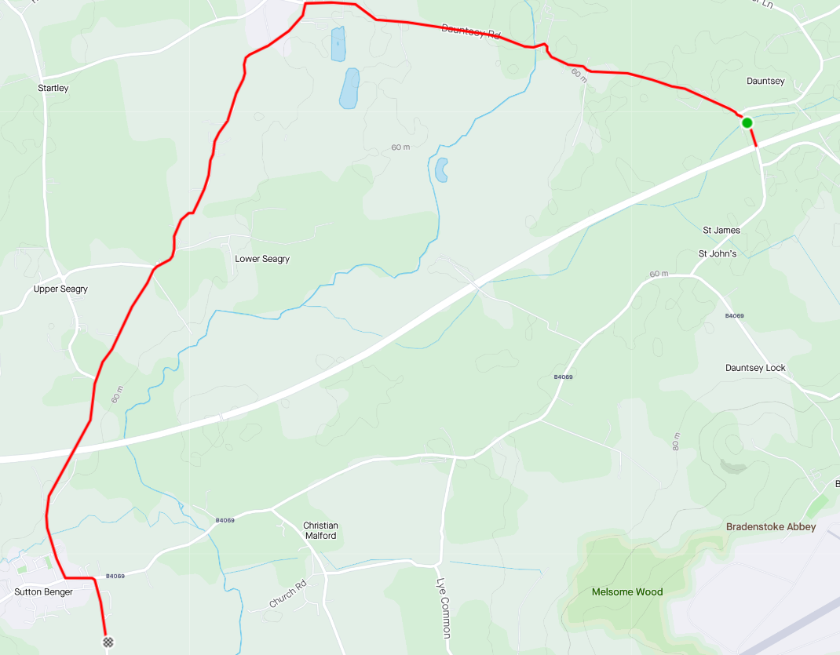

Your Course Notes (Personal Best, etc..
https://www.strava.com/activities/47807898
Avoids Idover Lane and B4069

UC868S | 13 Miles
Course Record:

Sign on in Queens Field, Sutton Lane

Start Sutton Benger
Finish on Seagry Road, North of Upper Seagry.

Map
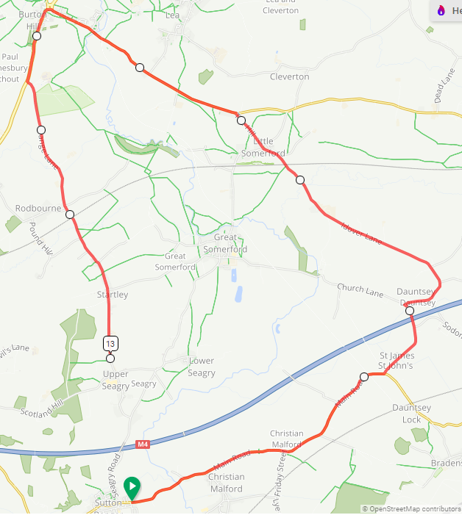

Your Course Notes (Personal Best, etc..
Avoids Great Somerford

U41: | 10 Mile Time Trial
Course Record:

Start in layby on unclassified road 0.3 mile north of Aggregate Industries entrance. Head south to junction of Spine Rd West and Spine Rd East (B4696) and turn left. Ride East along Spine Road East towards Cotswold Water Park and A419. Cross the double RAB (Marshal) over the A419 (straight on at first RAB) and turn right at second RAB (Marshal) (second exit) towards Latton (DO NOT TAKE A419 EXITS). Ride South East along Cirencester Road through village of Latton (note traffic calming road narrows) to RAB for A419 and circle RAB to return along Cirencester Road through Latton to the double RAB with A419. At first RAB take second exit (straight across) to second RAB (Marshal) and take second exit along Spine Rd East past Cotswold Water Park (DO NOT TAKE A419 EXITS). Ride West along Spine Rd East to finish 0.5 mile short of junction at West end of small gated layby before Clayhill Car Park
Map
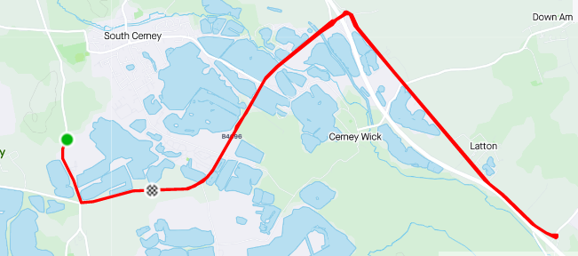

Your Course Notes (Personal Best, etc..
https://www.strava.com/segments/17572440
HQs Sports Pavilion or Village Hall in Ashton Keynes

U85 | 10 Mile Course
Course Record:

Sign on at Golf Club

Park in Woodbridge Golf Club car park off the B4042. Event HQ is Woodbridge Golf Club clubhouse.

Start at entrance to White Hill Farm (SU00466 84822)

Follow B4042 for 5 miles and circle RAB and retrace on B4042 towards Brinkworth. Go through Brinkworth to finish next to Eastern end of small layby next to Woodbridge Golf Course entrance (SU00190 84980)
Map
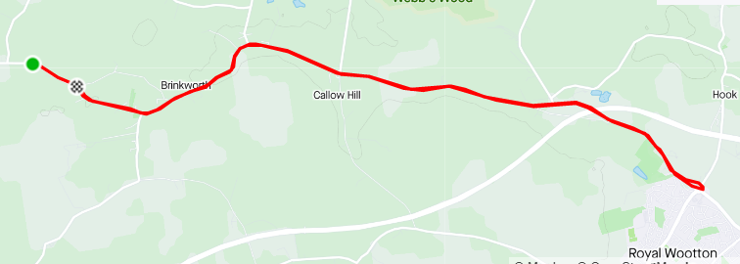

Your Course Notes (Personal Best, etc..
https://www.strava.com/segments/8021132

U86/25: | 25 Mile Time Trial
Course Record:

Little Somerford Village Hall

Start in Bus Stop area on The Hill, Little Somerford (OS ST966849) south of B4042

Turn left onto B4042 proceed west toward Malmesbury RAB with A429. Circle RAB and come back east on B4042 towards Brinkworth. Through Brinkworth to Ballards Ash junction with B4696. Turn left to Purton Road X-roads. Turn left to Baydon Manor and Minety. At X-roads on B4040 turn left to Malmesbury Watertower RAB. Turn left at RAB south on A429 towards RAB with A429/B4042. Turn left at RAB back onto B4042 east towards Brinkworth to finish eastern end of layby opposite Clay Street/B4042 Junction by Lovett Farm. (OS ST973850

Map
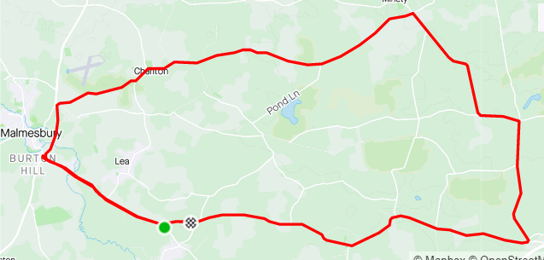

Your Course Notes (Personal Best, etc..
https://www.strava.com/segments/15238378

Course Record:

Sign on in Queens Field, Sutton Lane

Start
finish
Map

Your Course Notes (Personal Best, etc..

